**Automated Network Request Management in ServiceNow**

**Project Description:**

This project aims to design and implement a streamlined, automated solution for managing network-related service requests within ServiceNow. It enables end users to submit requests for network services through a user-friendly self-service portal.

The system leverages ServiceNow’s workflow engine, catalog items, and approval processes to ensure requests are properly captured, validated, and routed for fulfillment. Upon submission, requests trigger automated notifications, task assignments, and—where applicable—integration with network automation tools or scripts to fulfill standard requests without manual intervention.

**Key Features:**

* Custom service catalog for common network requests
* Dynamic forms to capture relevant request details
* Automated approval workflows based on request type and sensitivity
* Integration with infrastructure management or orchestration tools (optional)
* Real-time status updates and notifications to requesters and technicians

**Service Catalog Creation**

**a. Creation of Service Catalog**

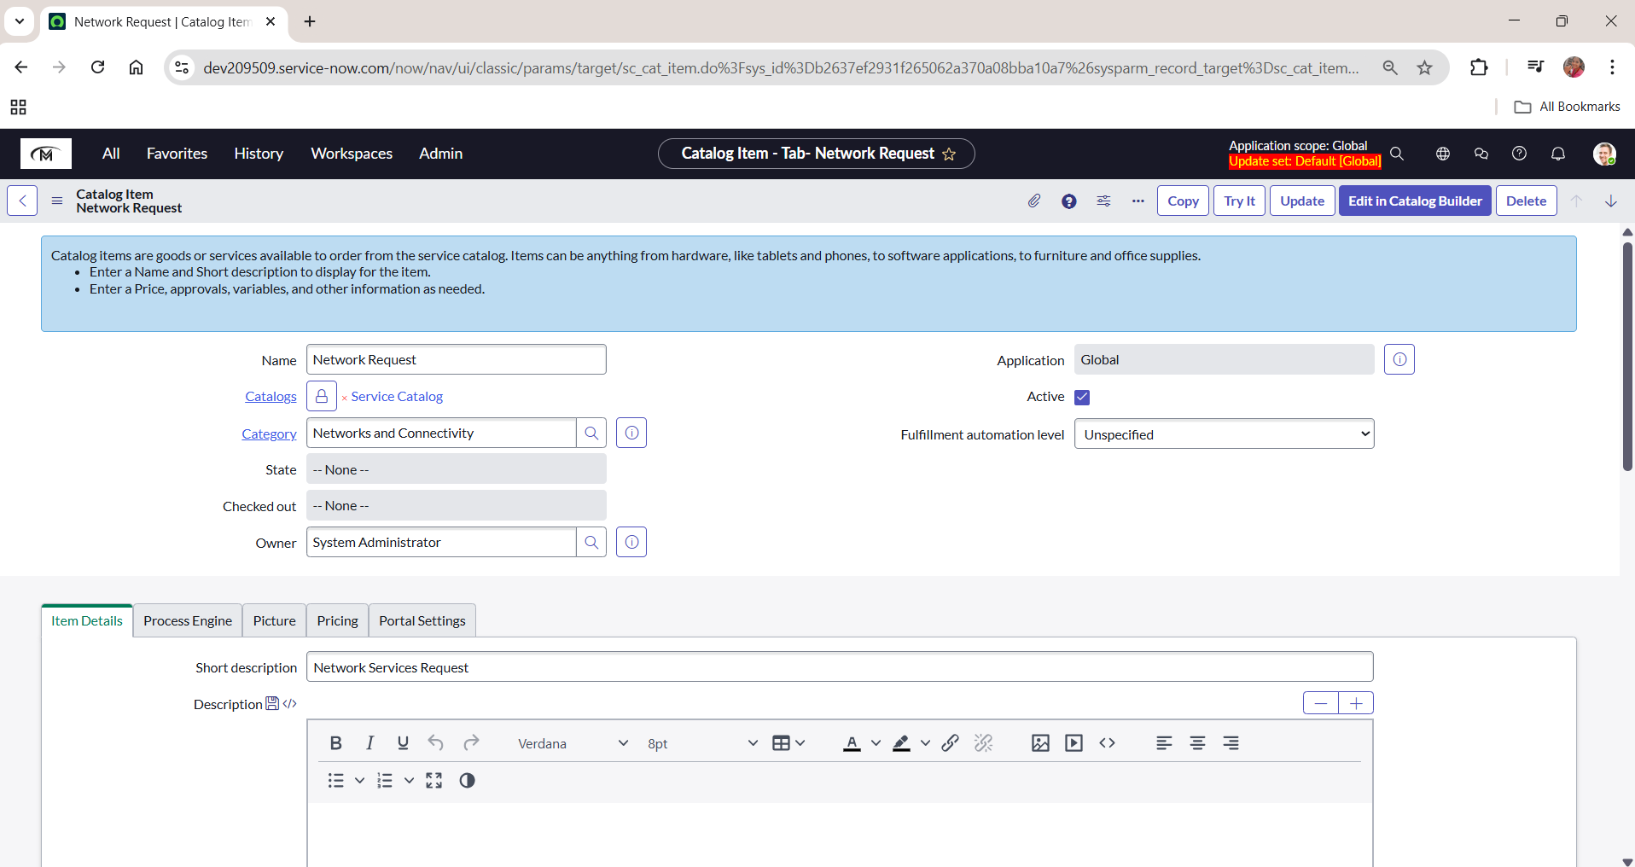



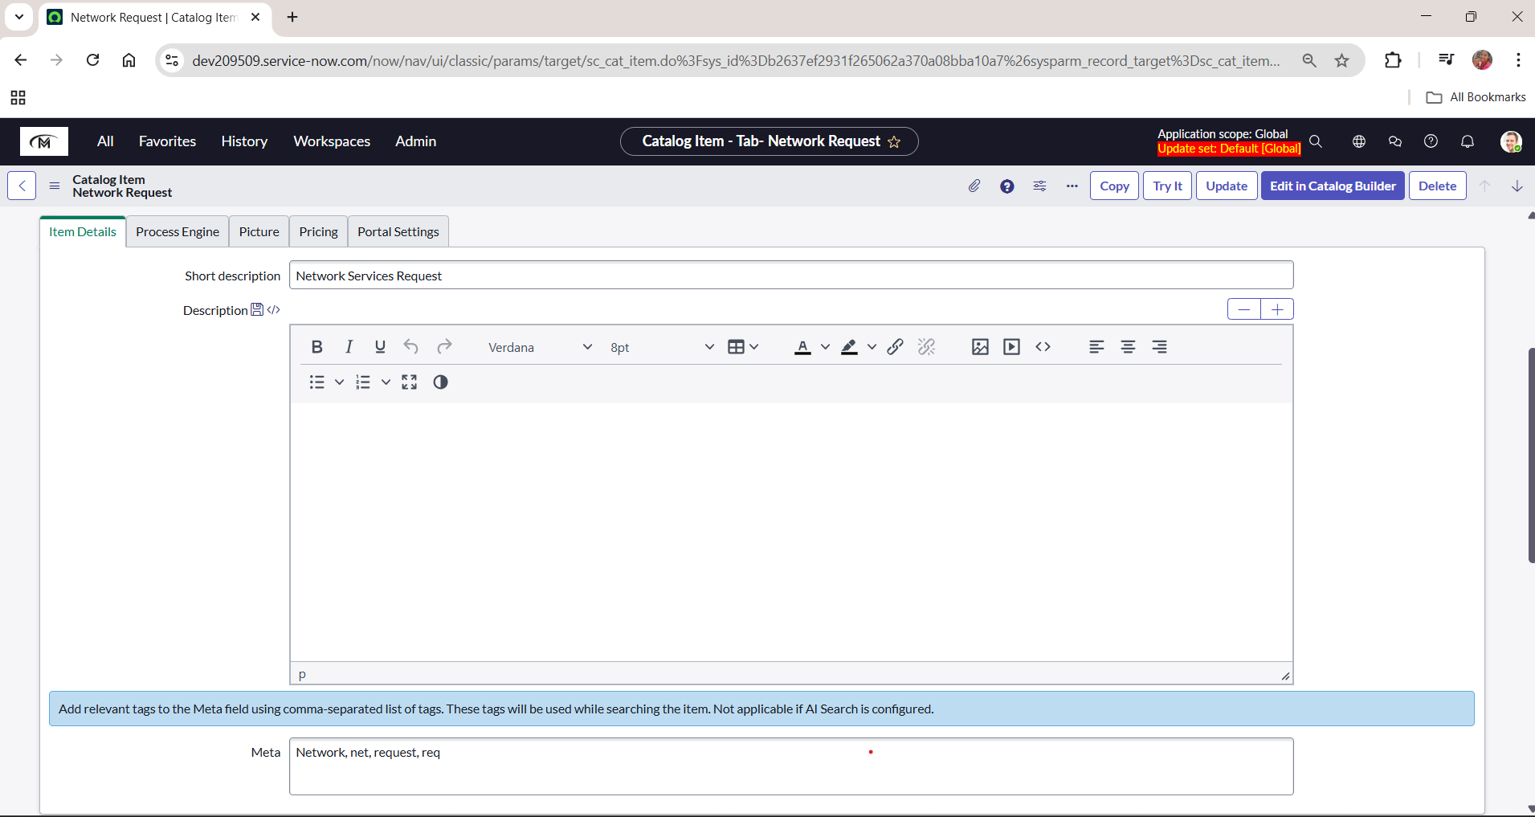

**b. Variables Configuration**

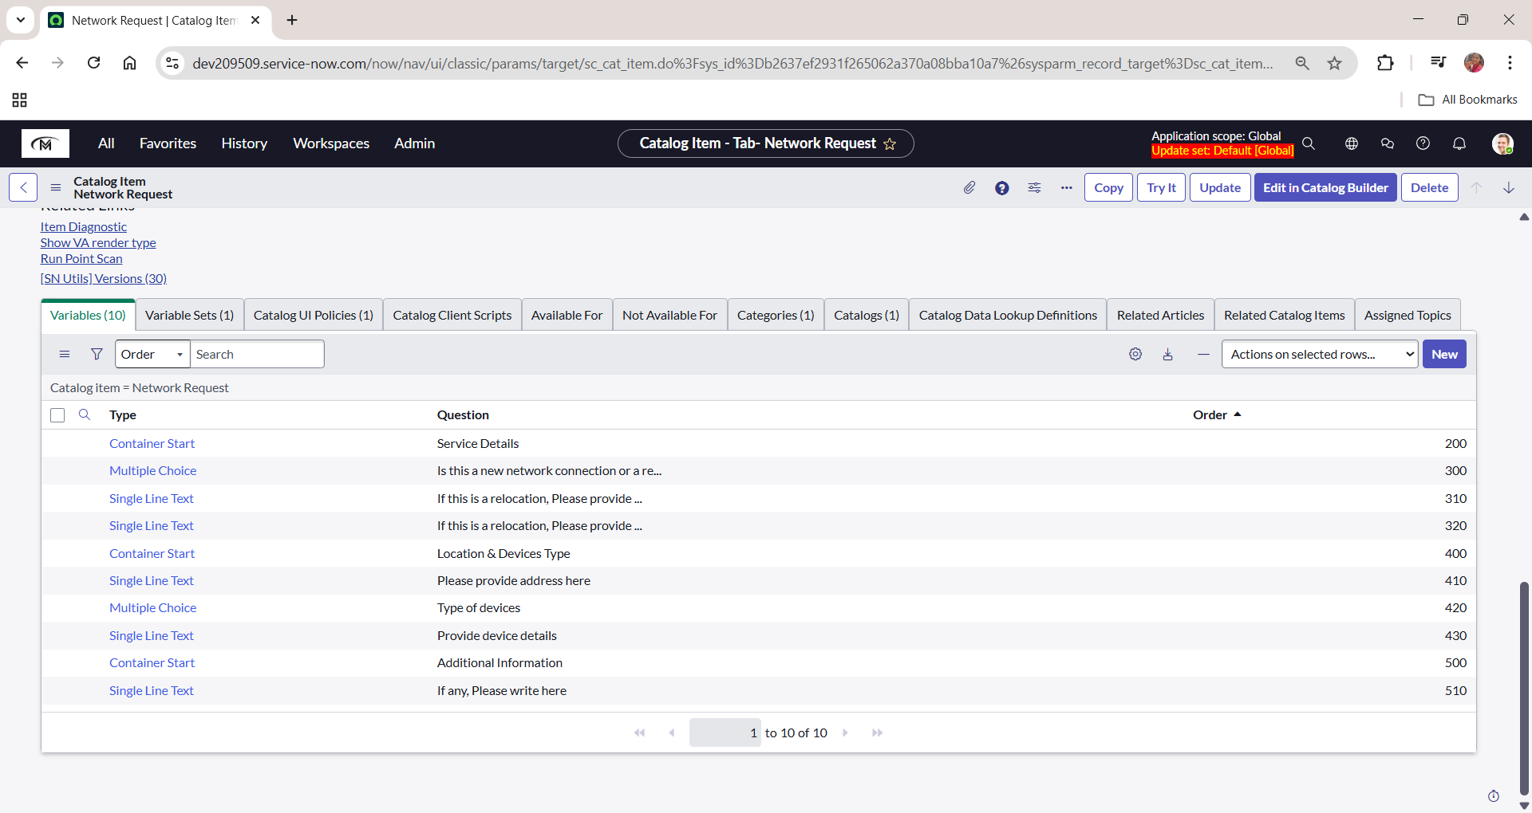

**c. Variables Types**

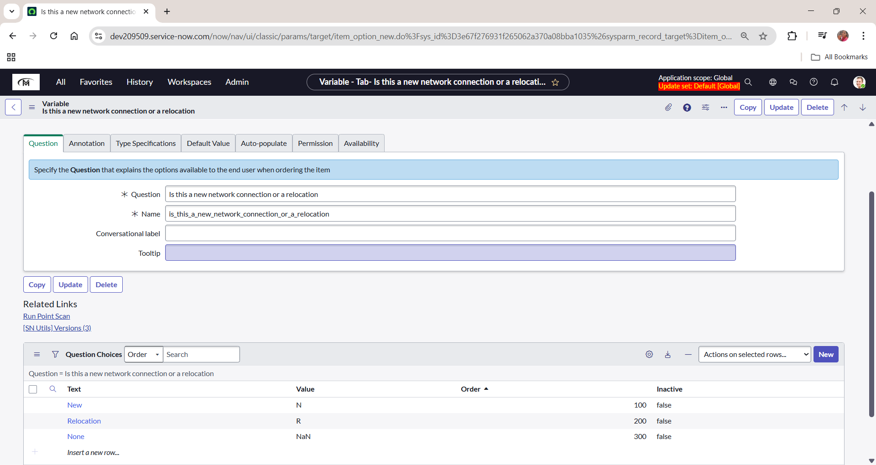

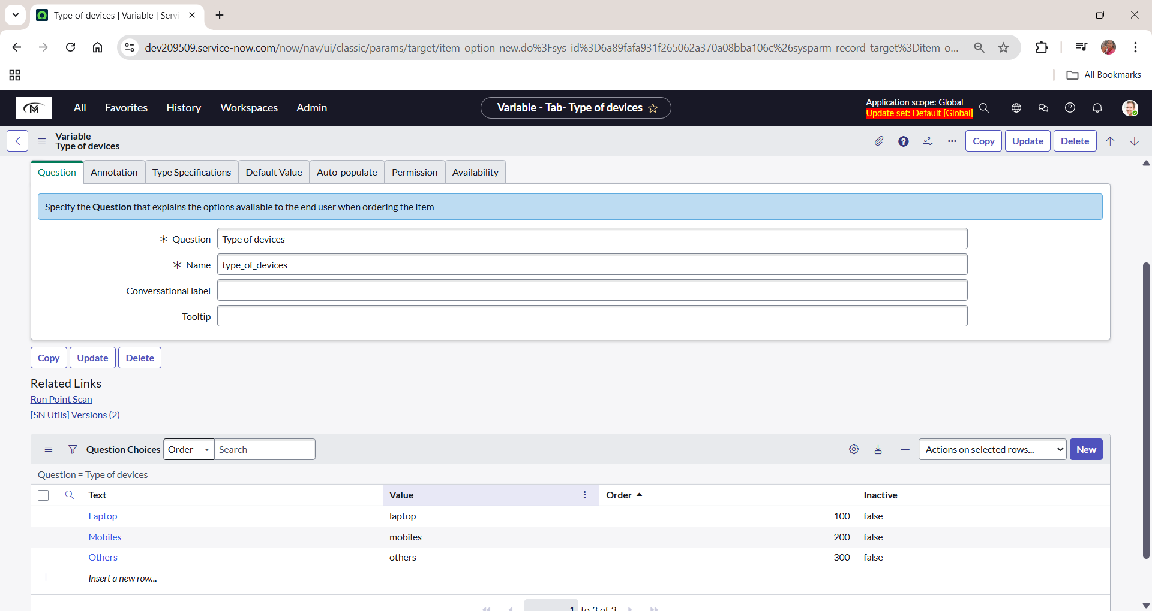

**d. Variable Set Configuration**

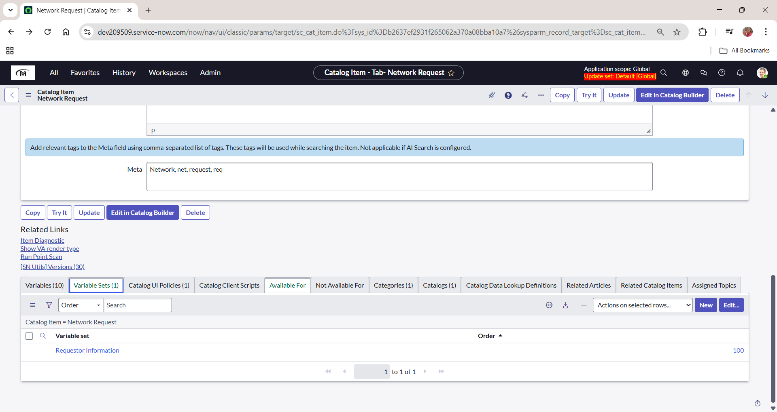

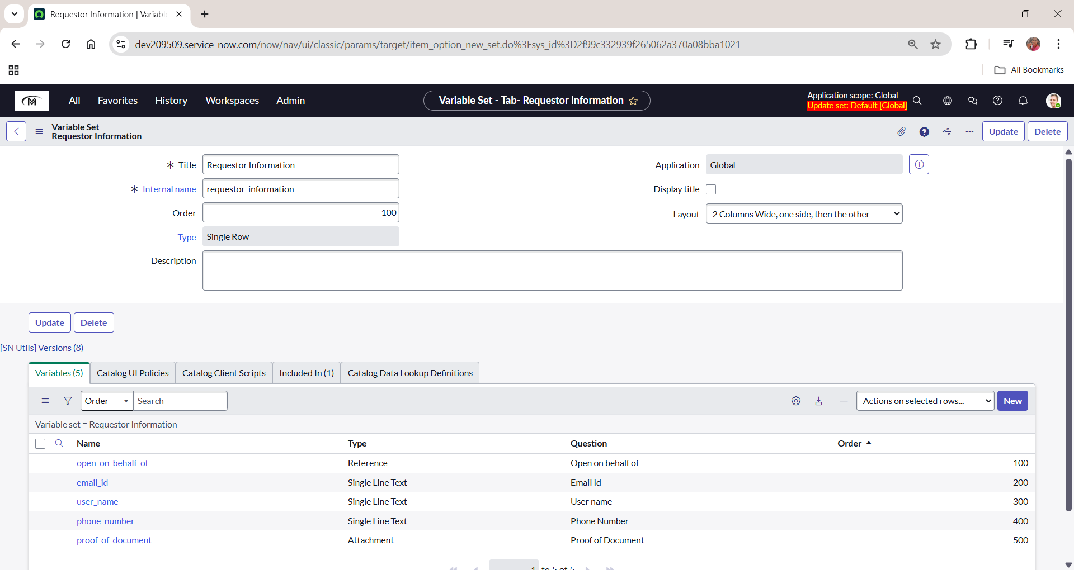

**e. Catalog UI Policy Configuration**

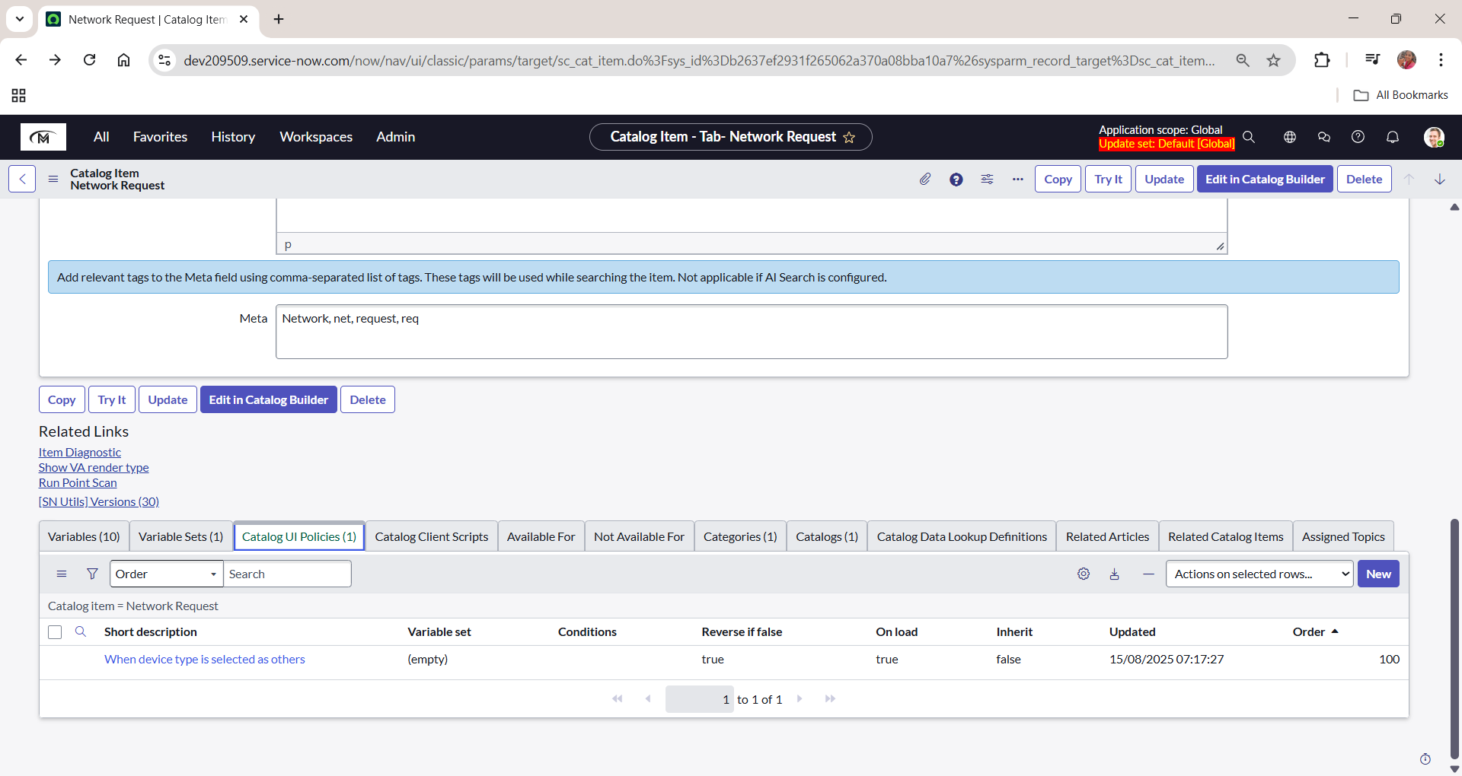

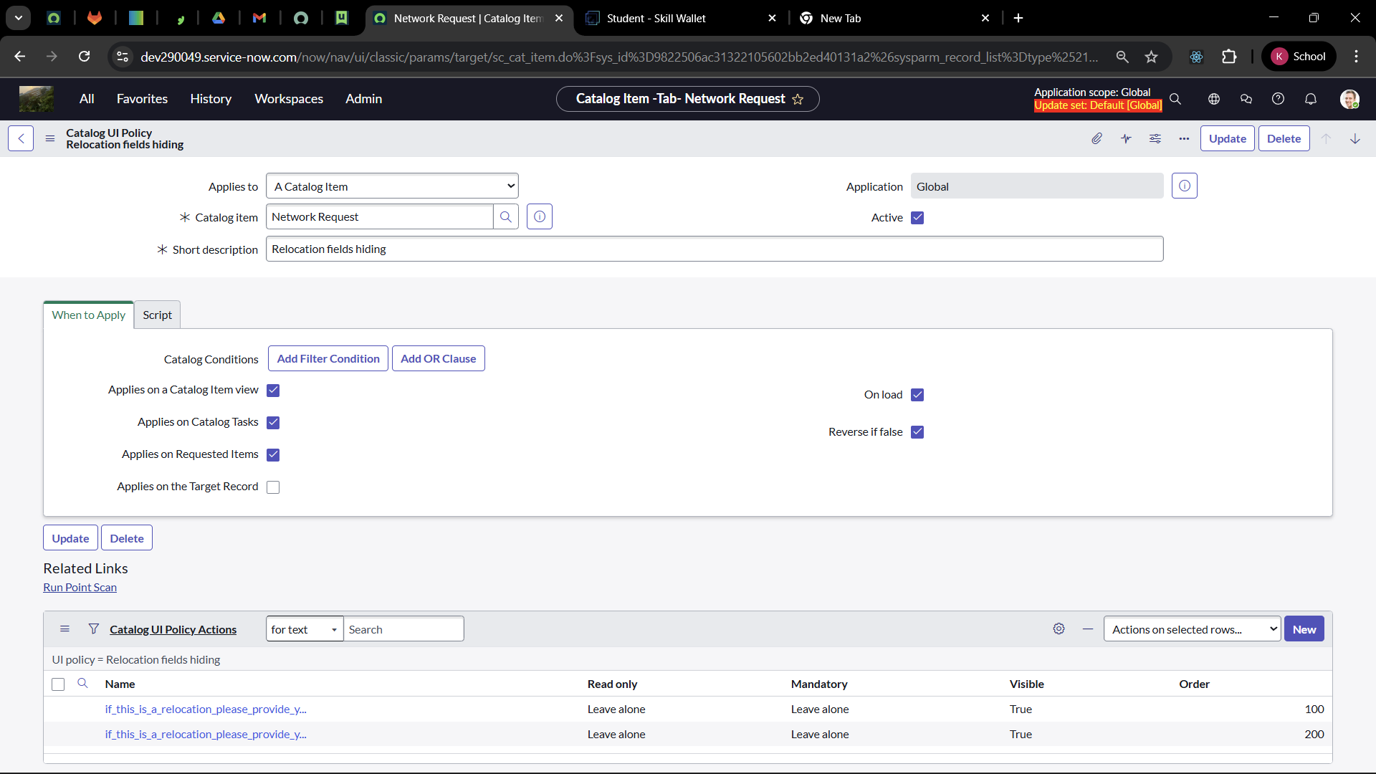

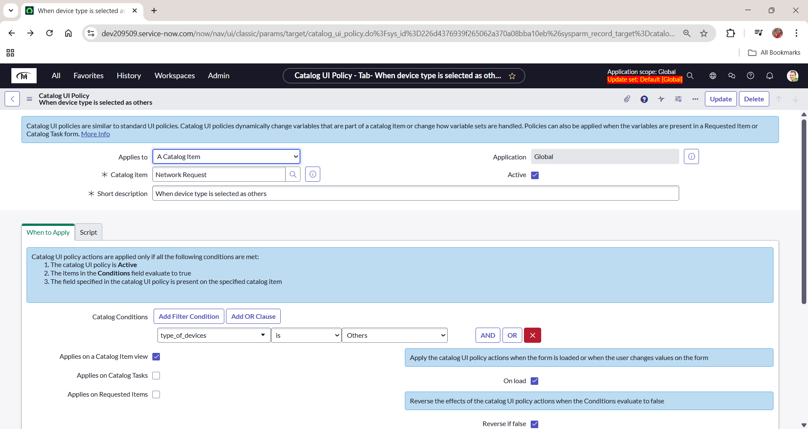

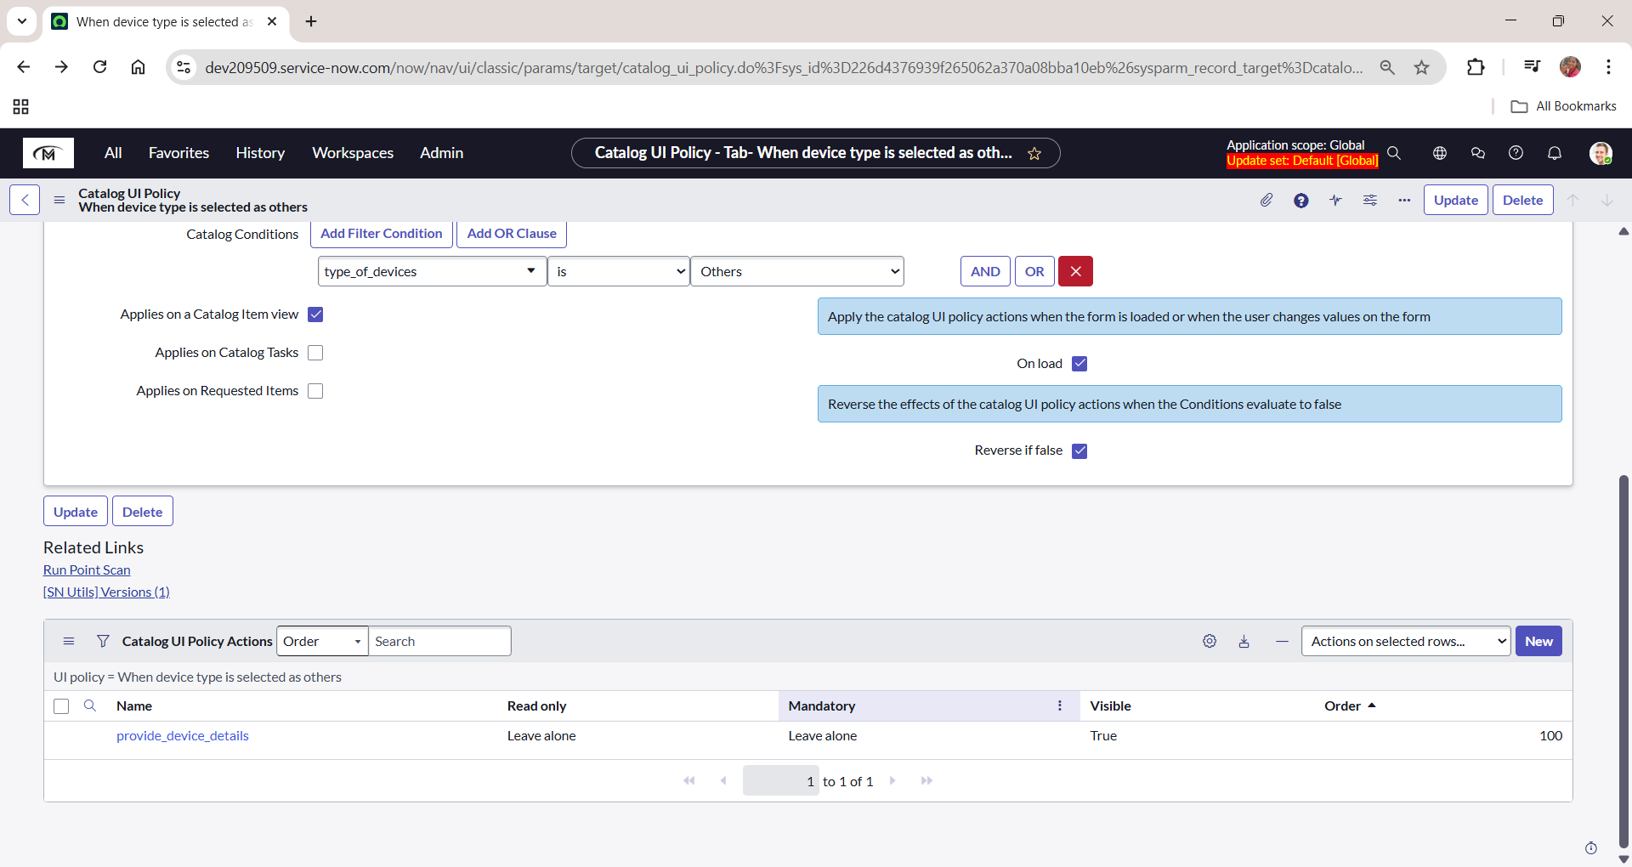

**Creation of Table**

**a. Creation of Table**

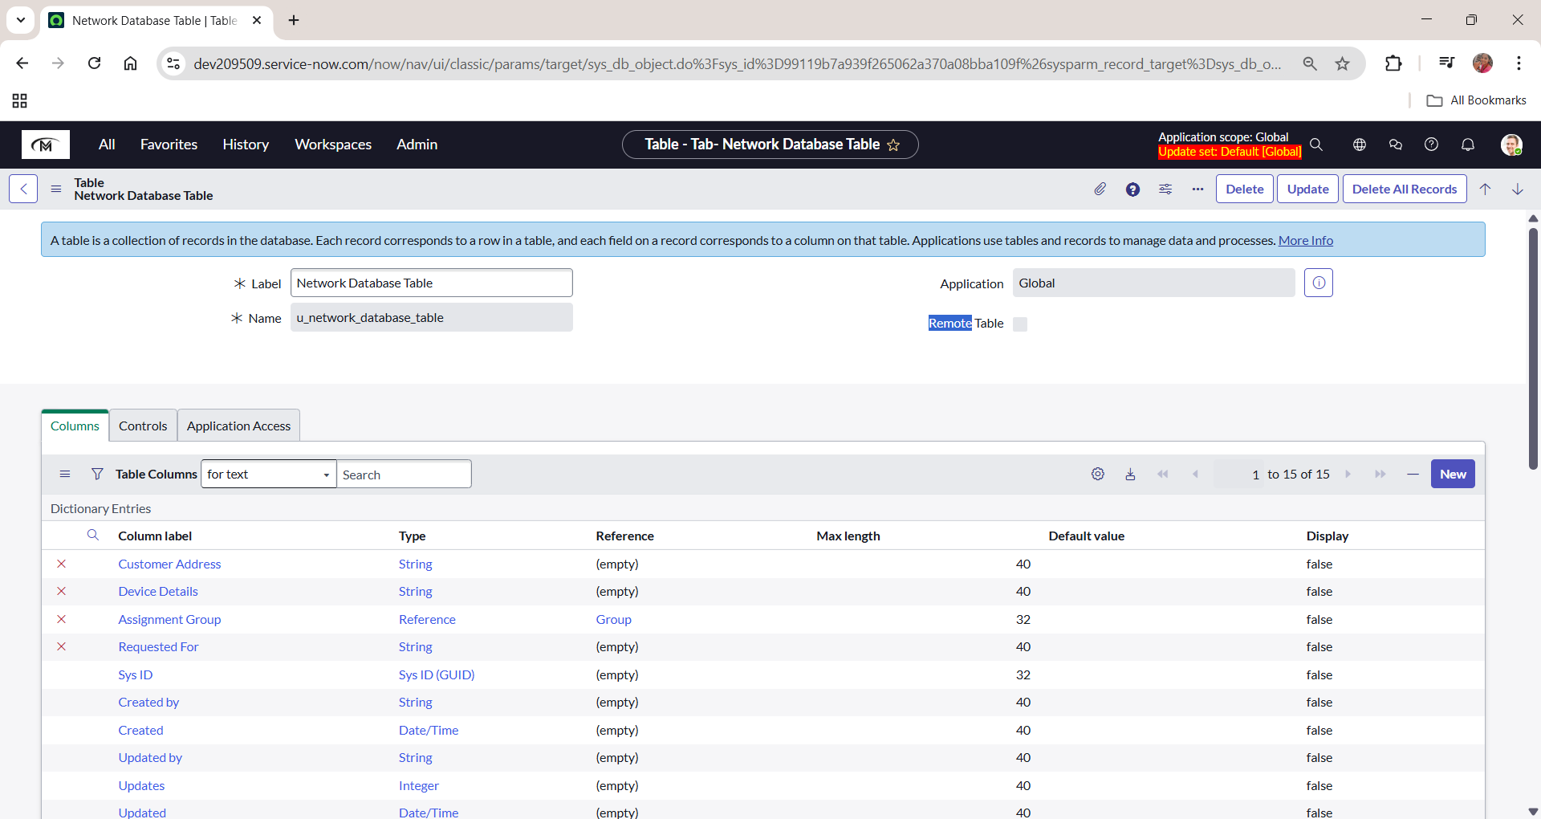

b. **Creation of fields**

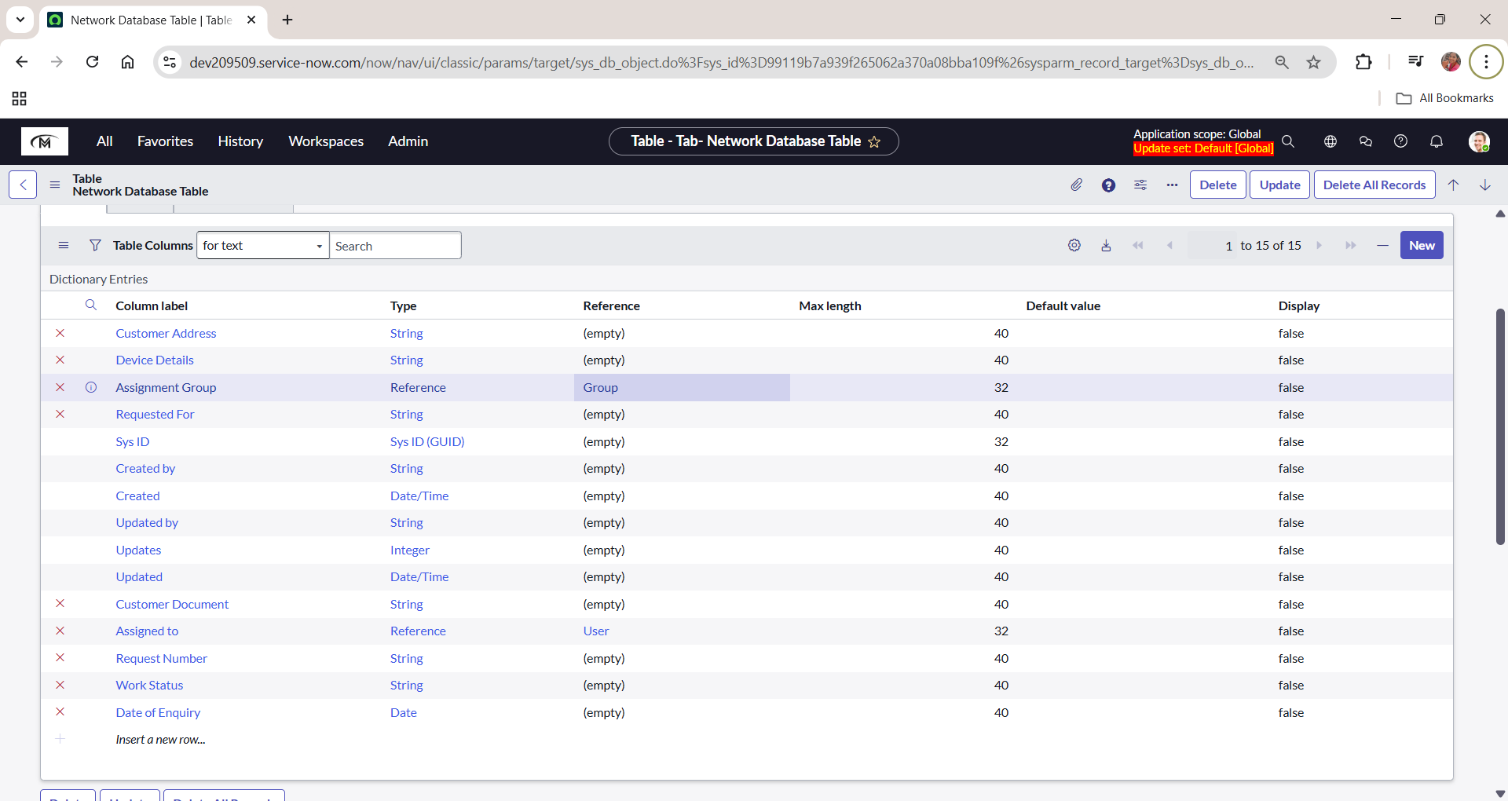

**Request Approvals Creation(Related List)**

**a. Creation of Related List**

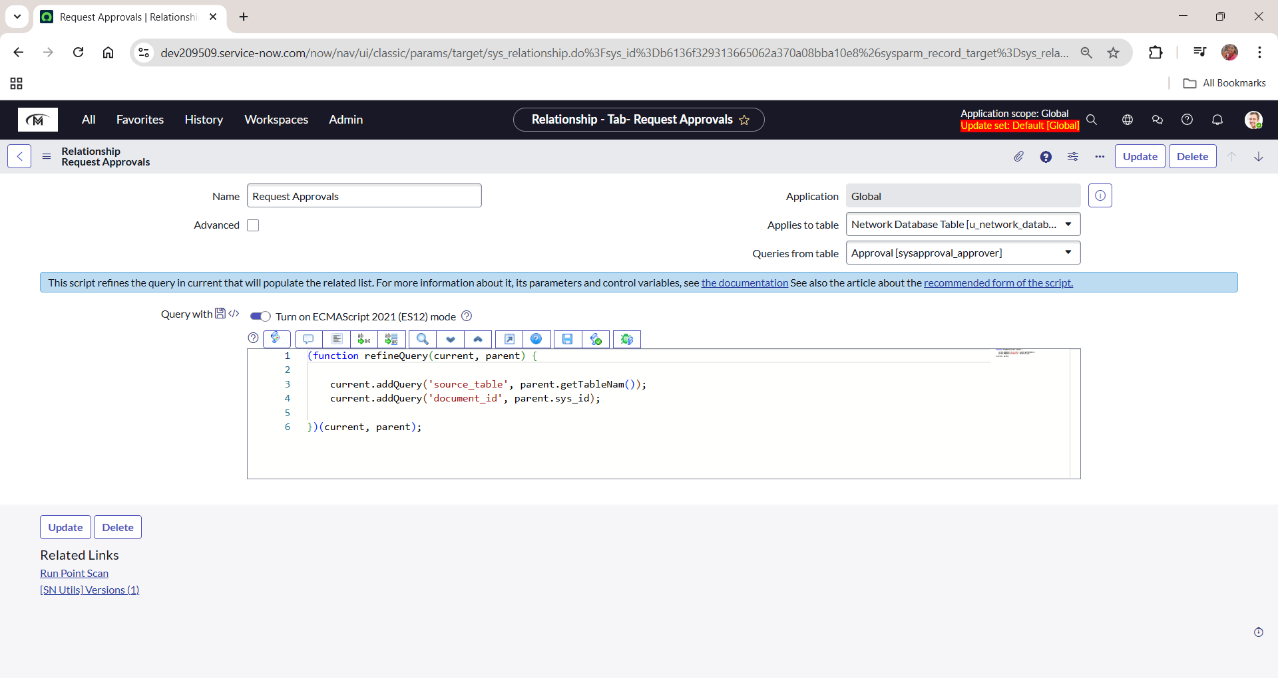

**b. Adding Related List to the Table**

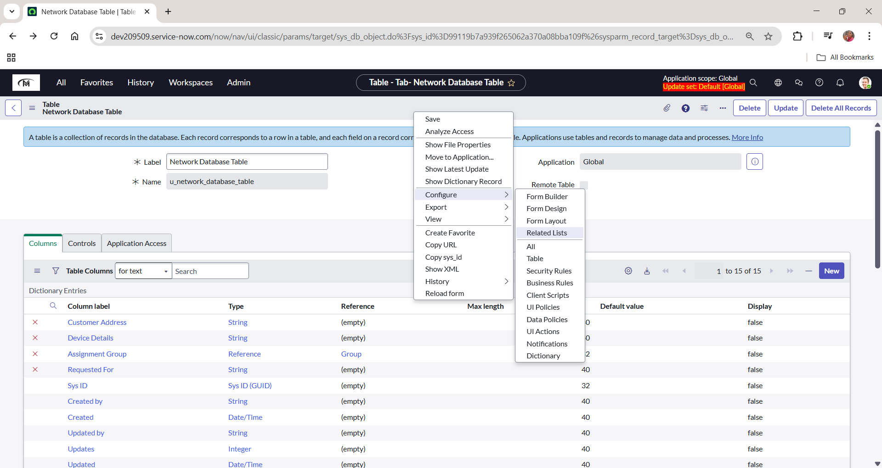

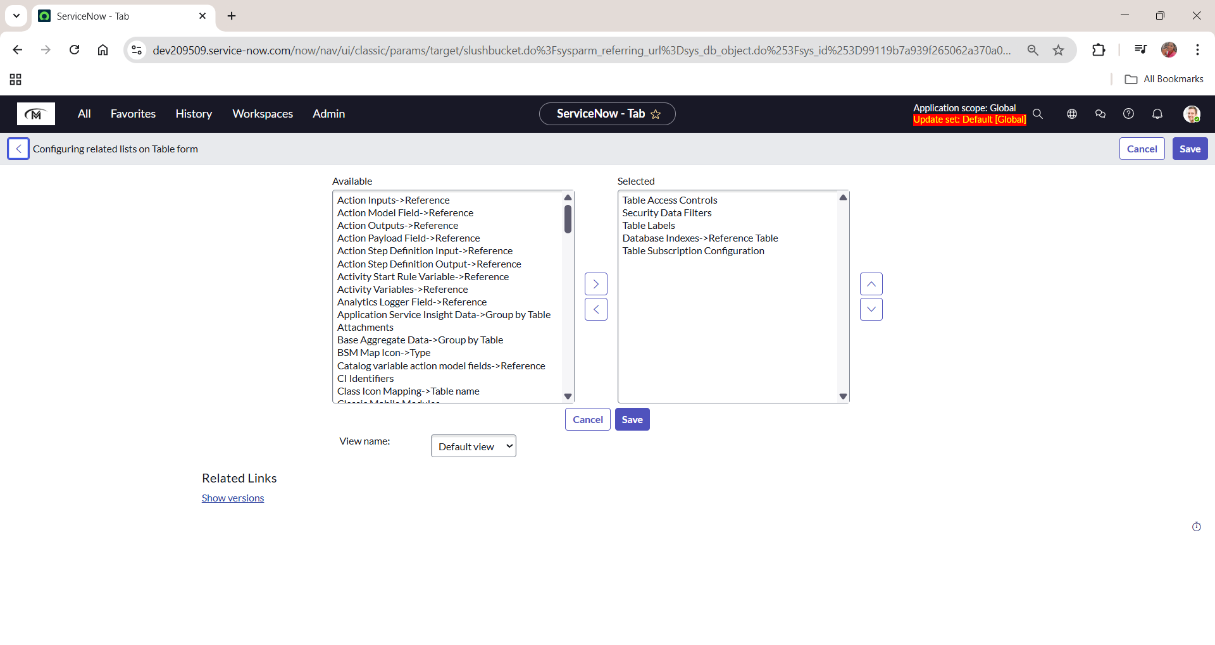

**Overview of flows,Actions in Flow Designera**

**a. Navigating to Flow Designer**

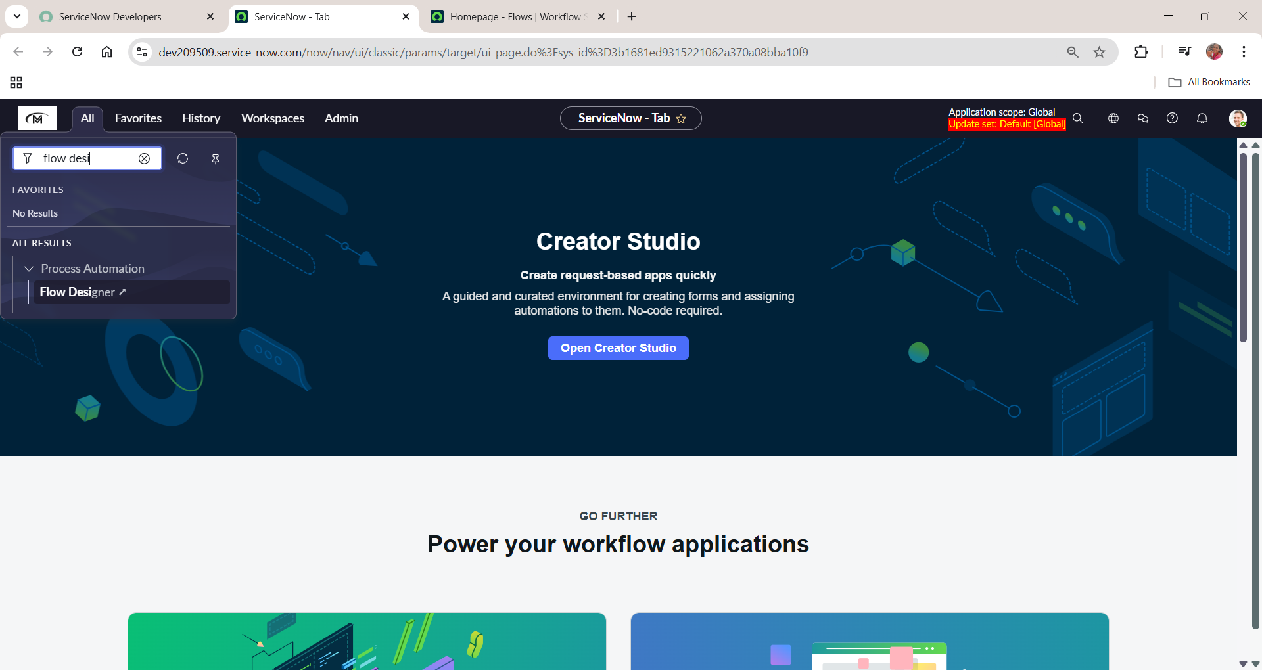

**Creation & Implementation of flows, Actions in Flow Designer**

**a. Creation of Flow**

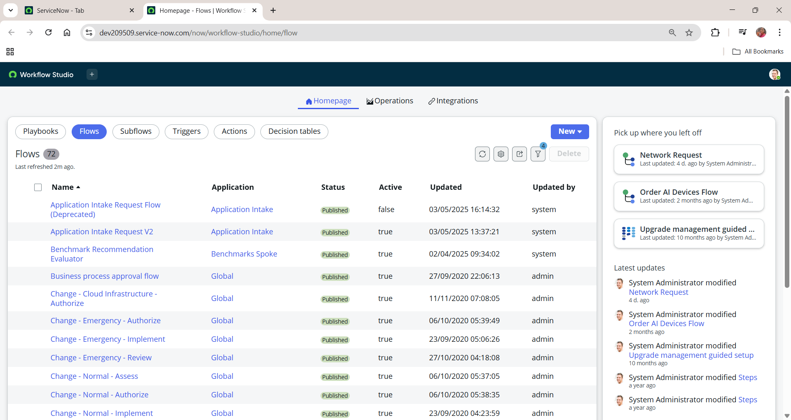

**b. Configuring Trigger**

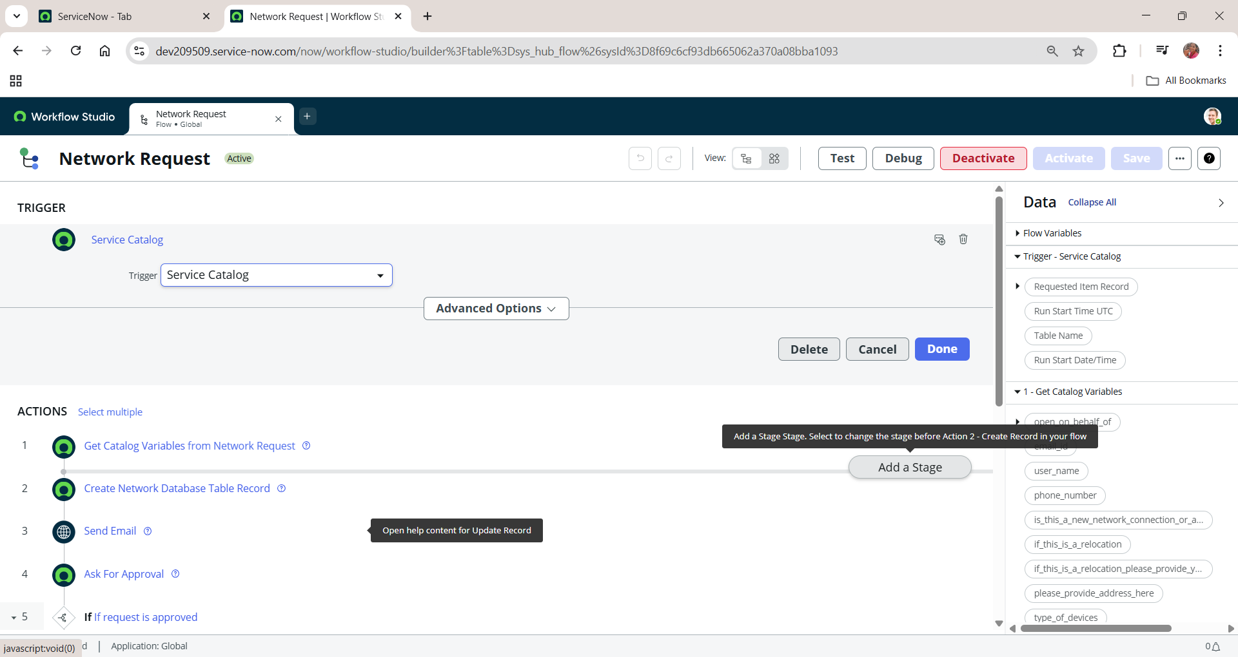

**c. Configuring Actions**

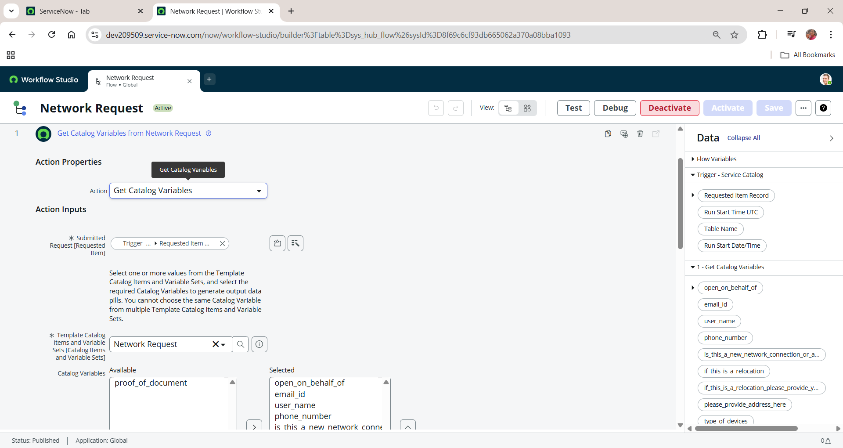

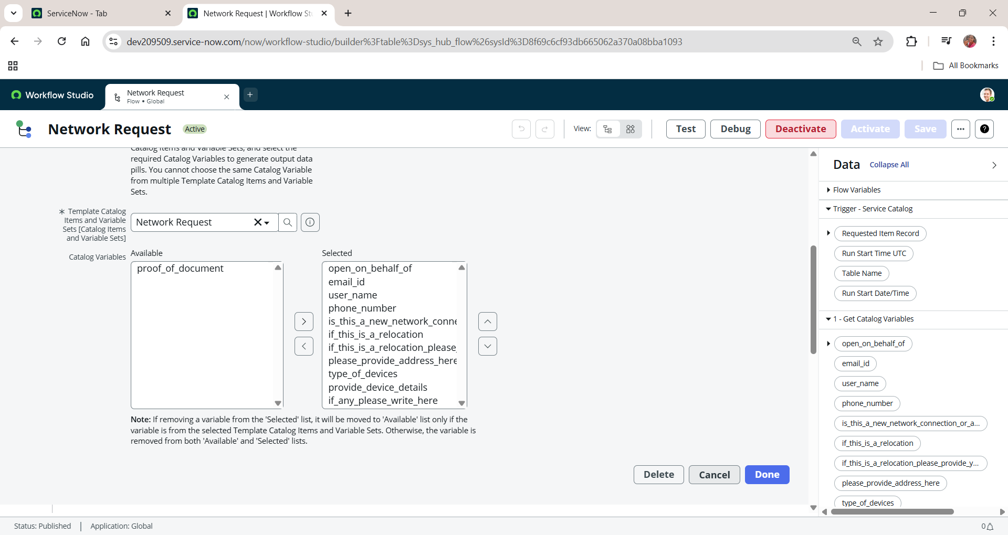

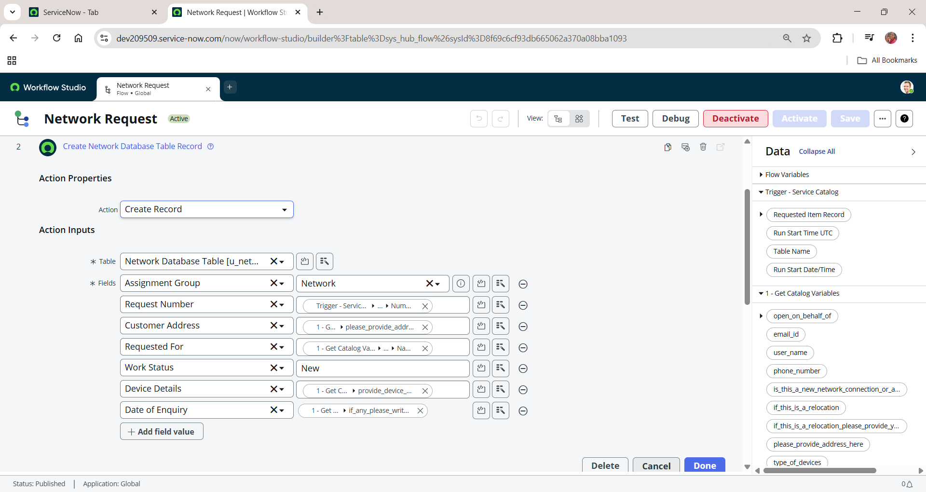

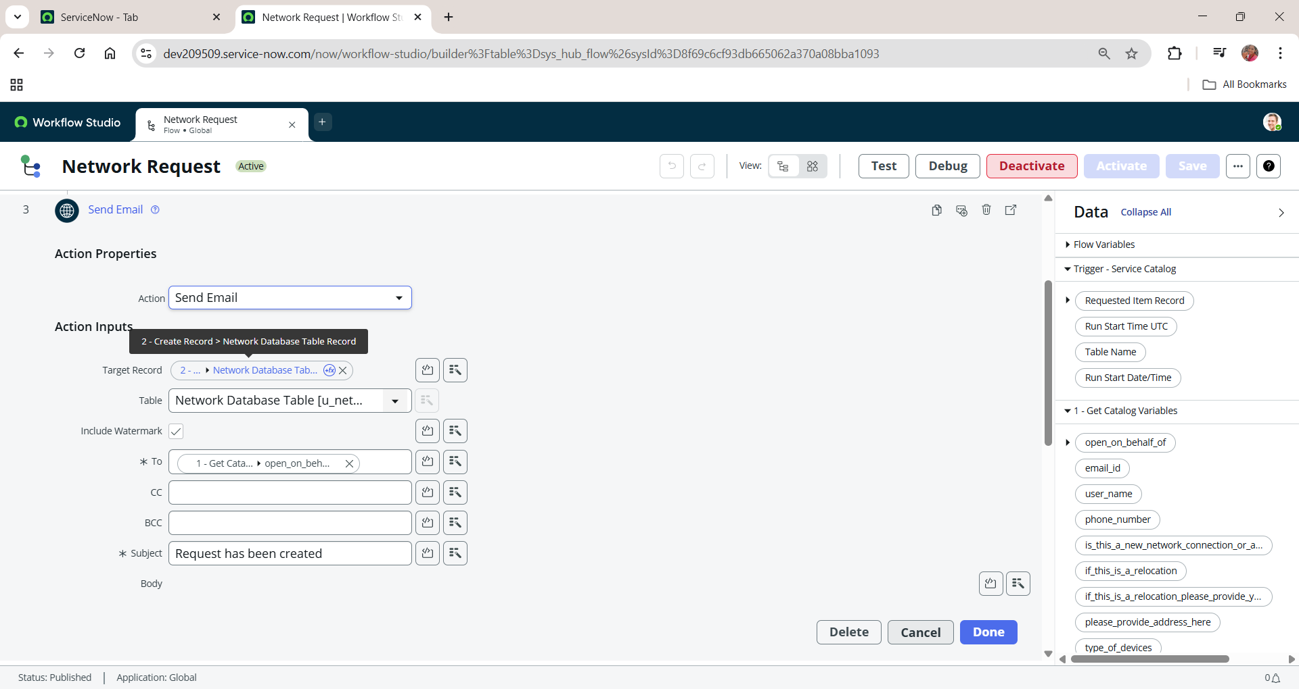

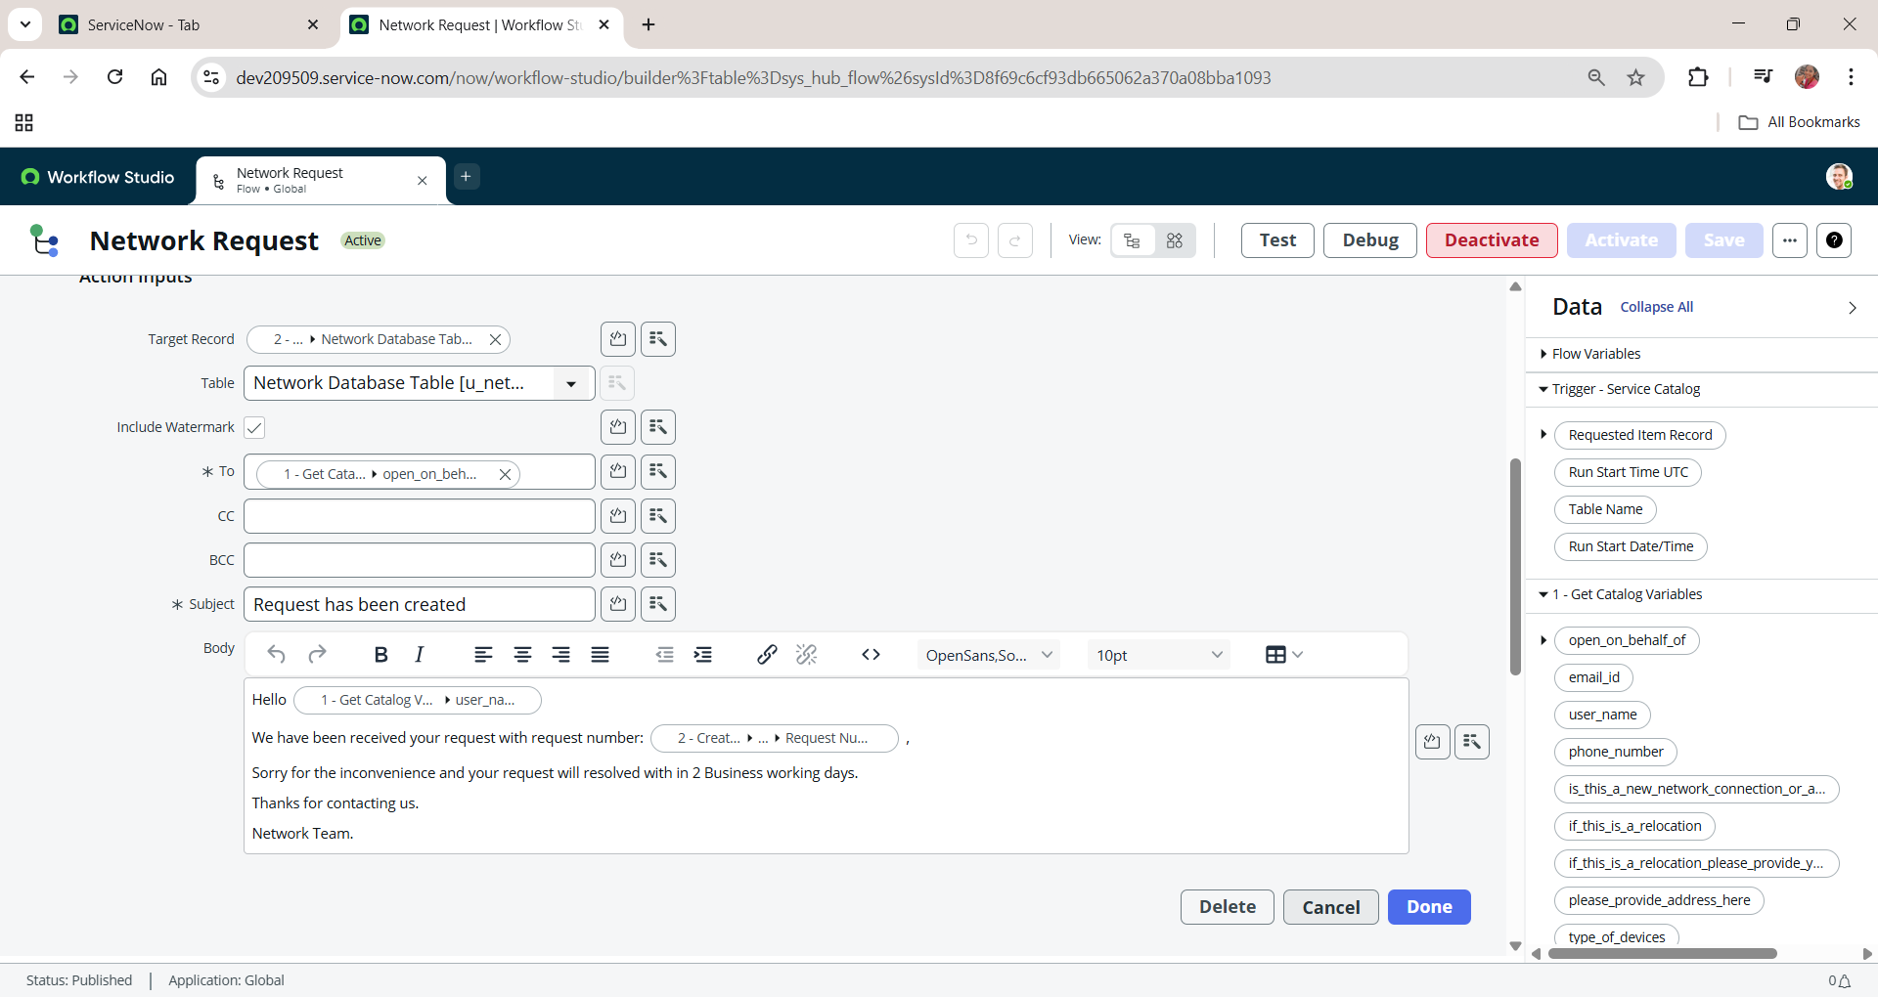

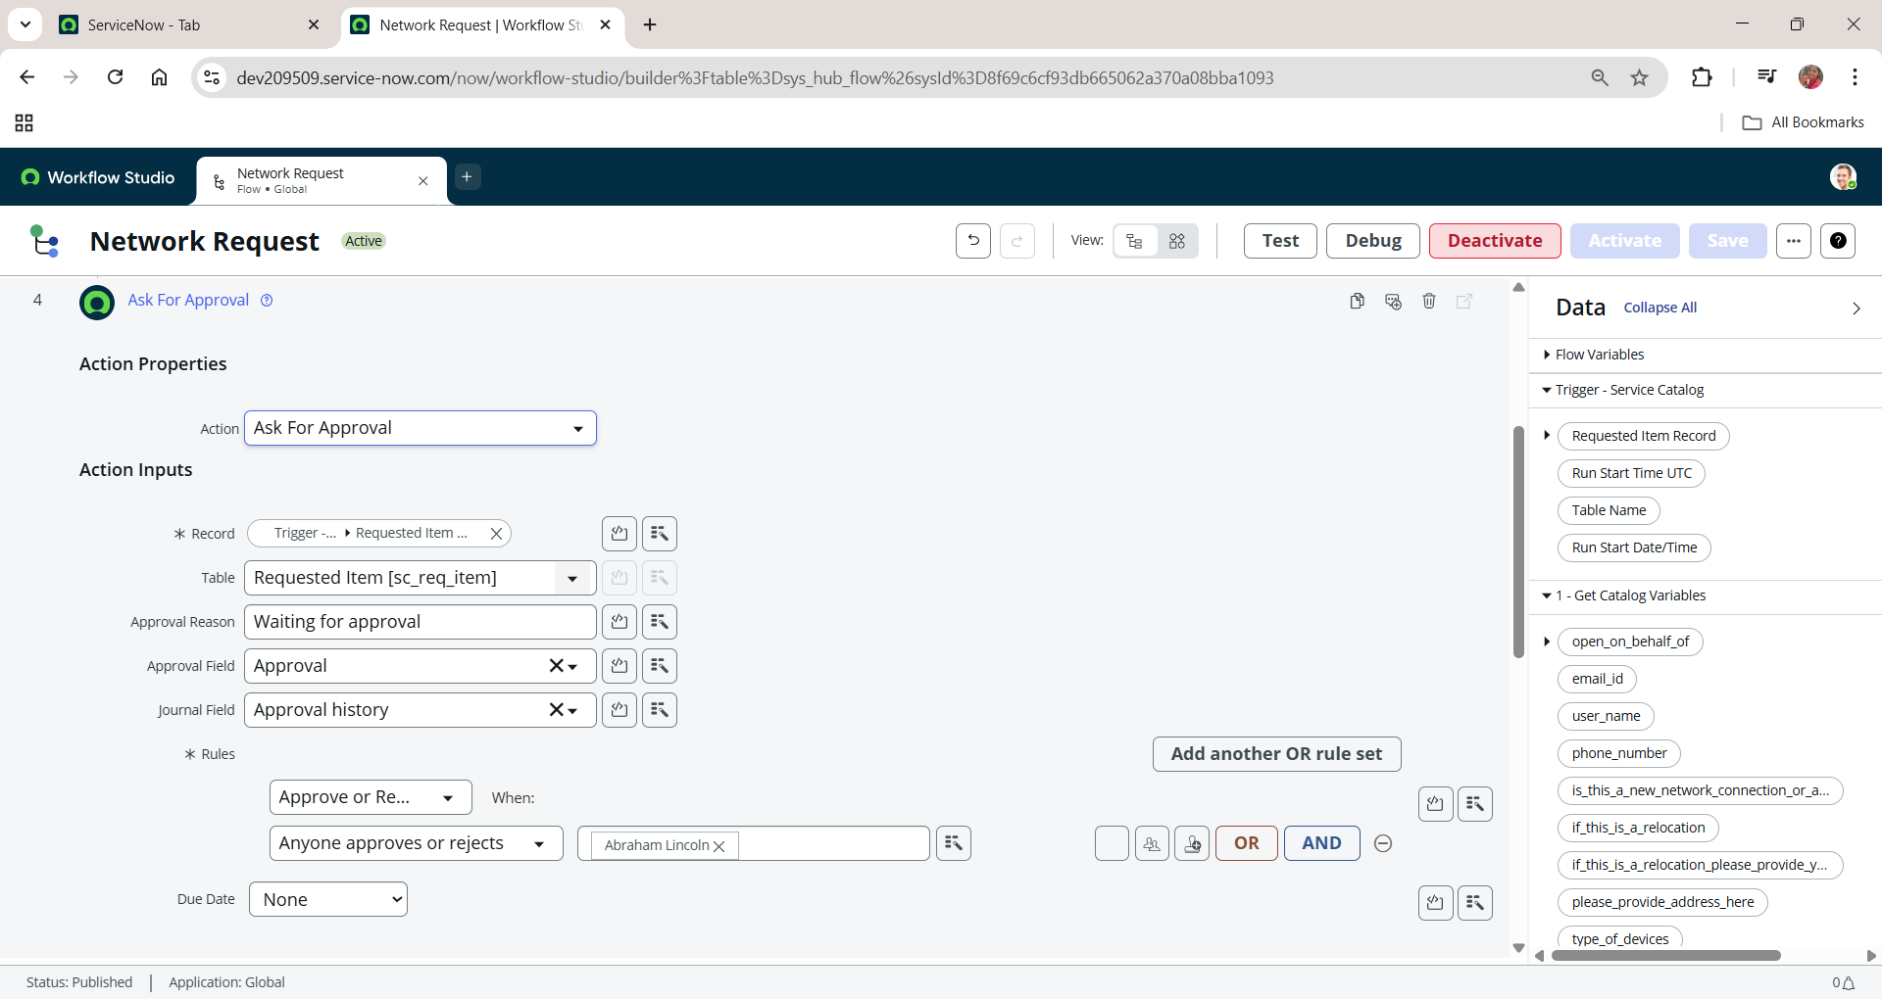

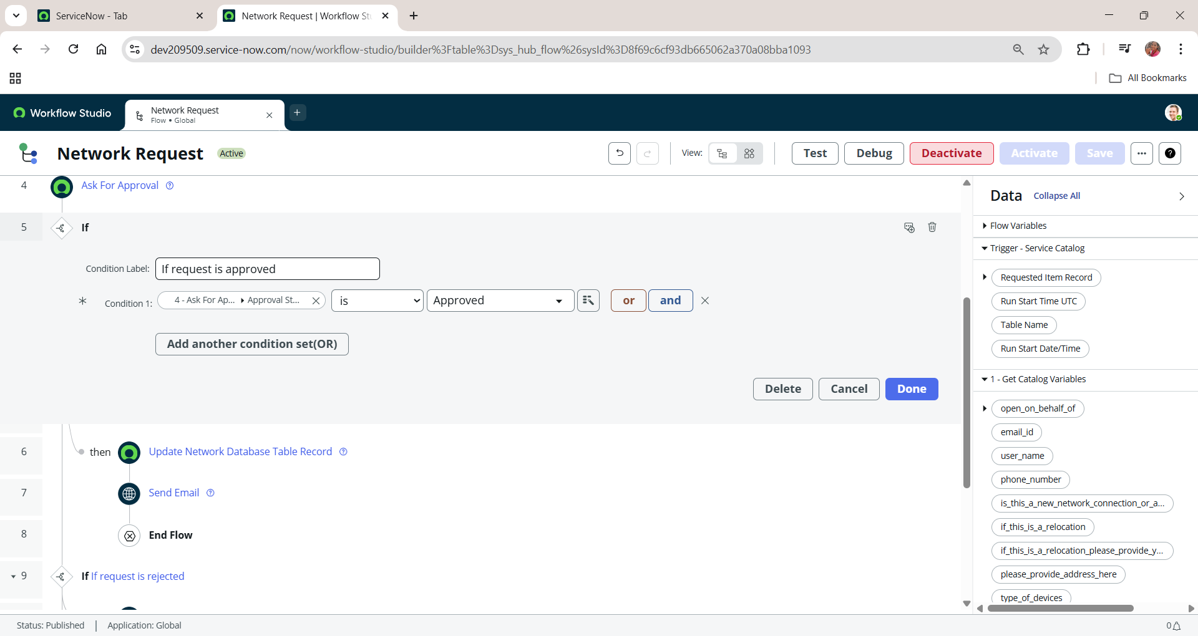

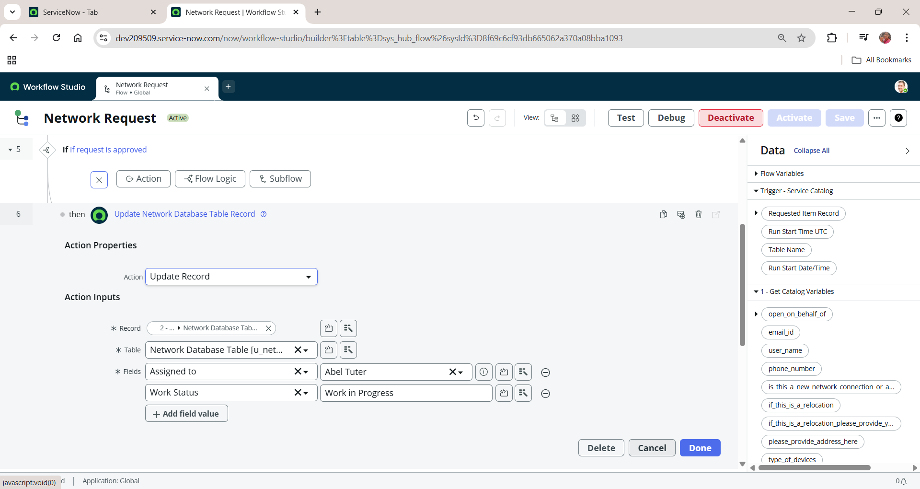

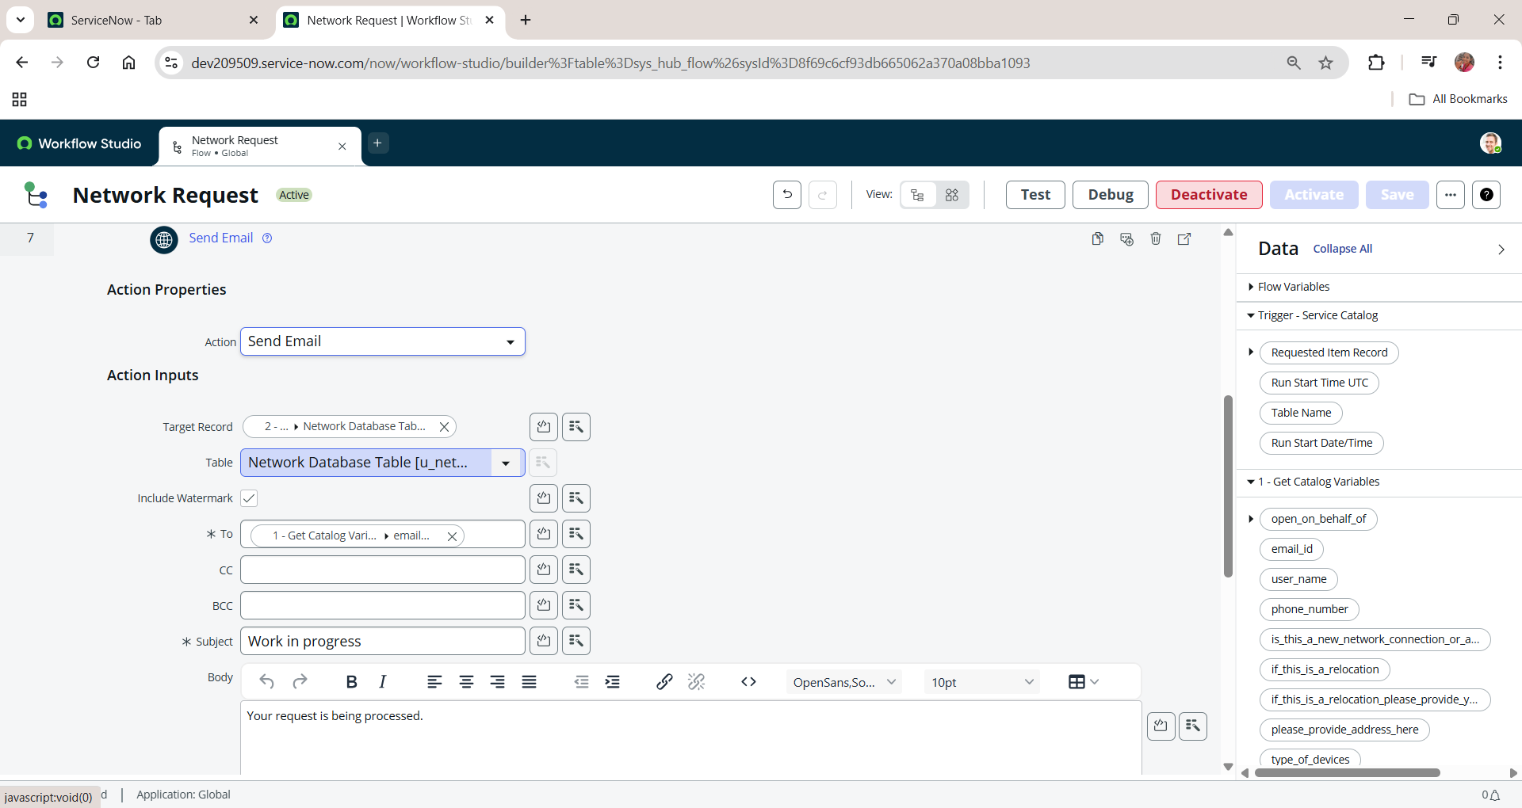

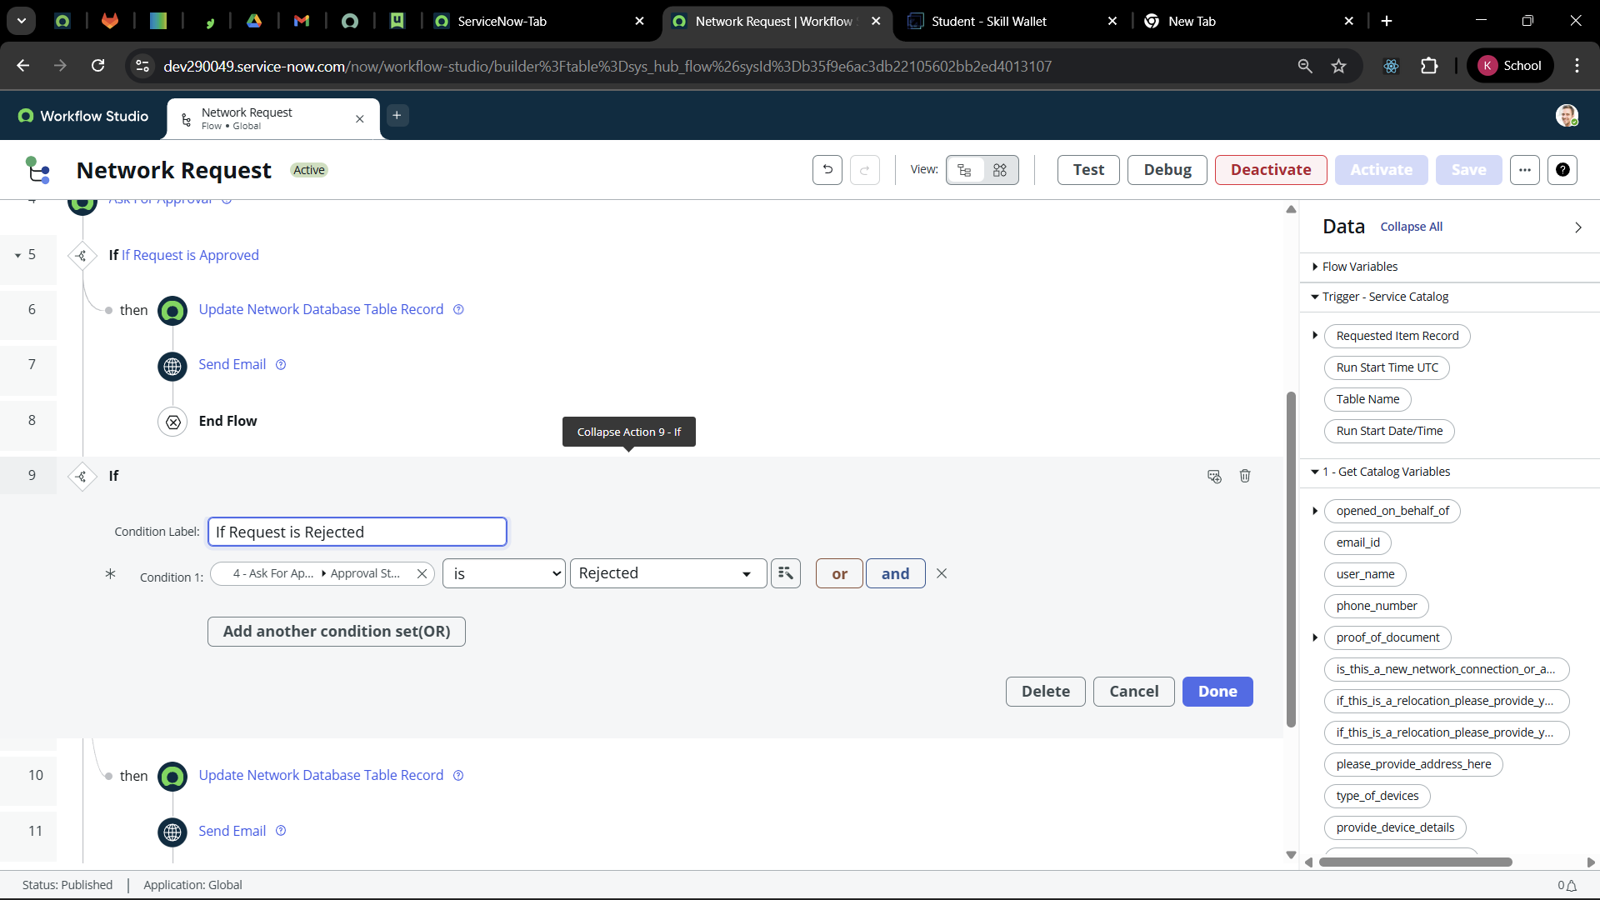

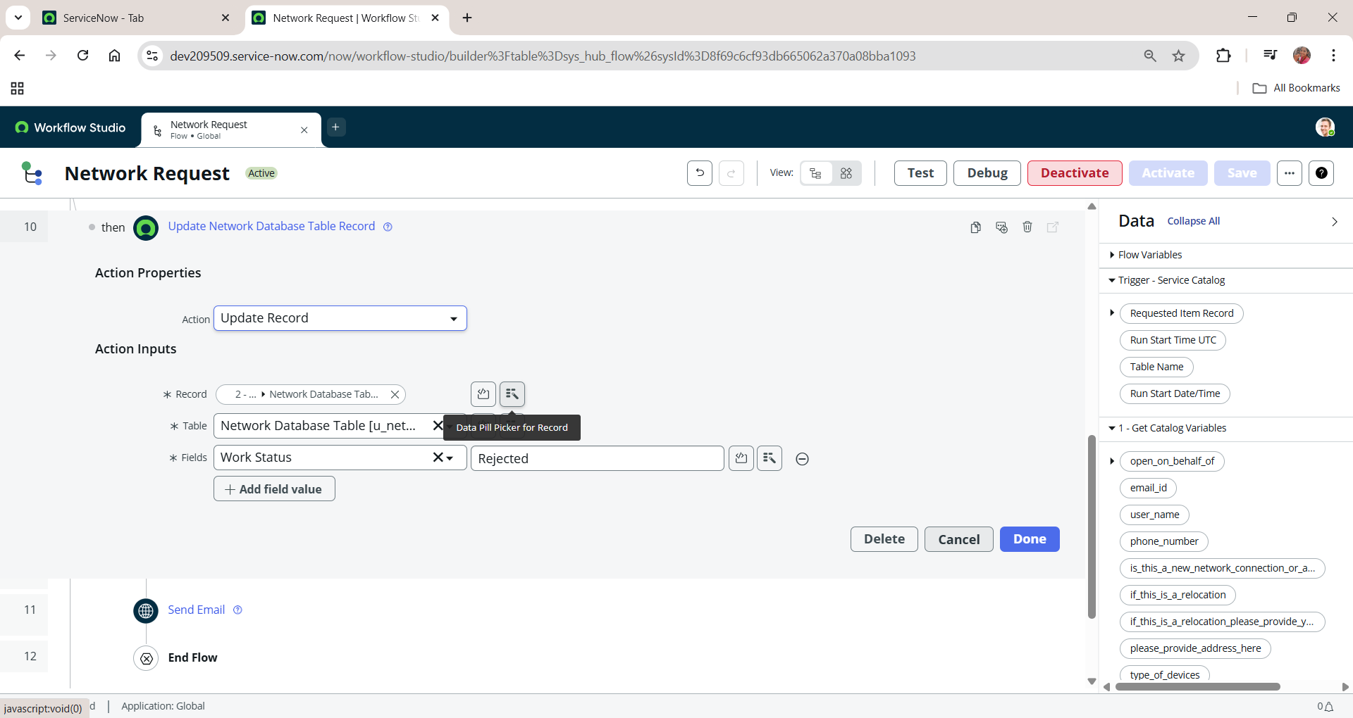

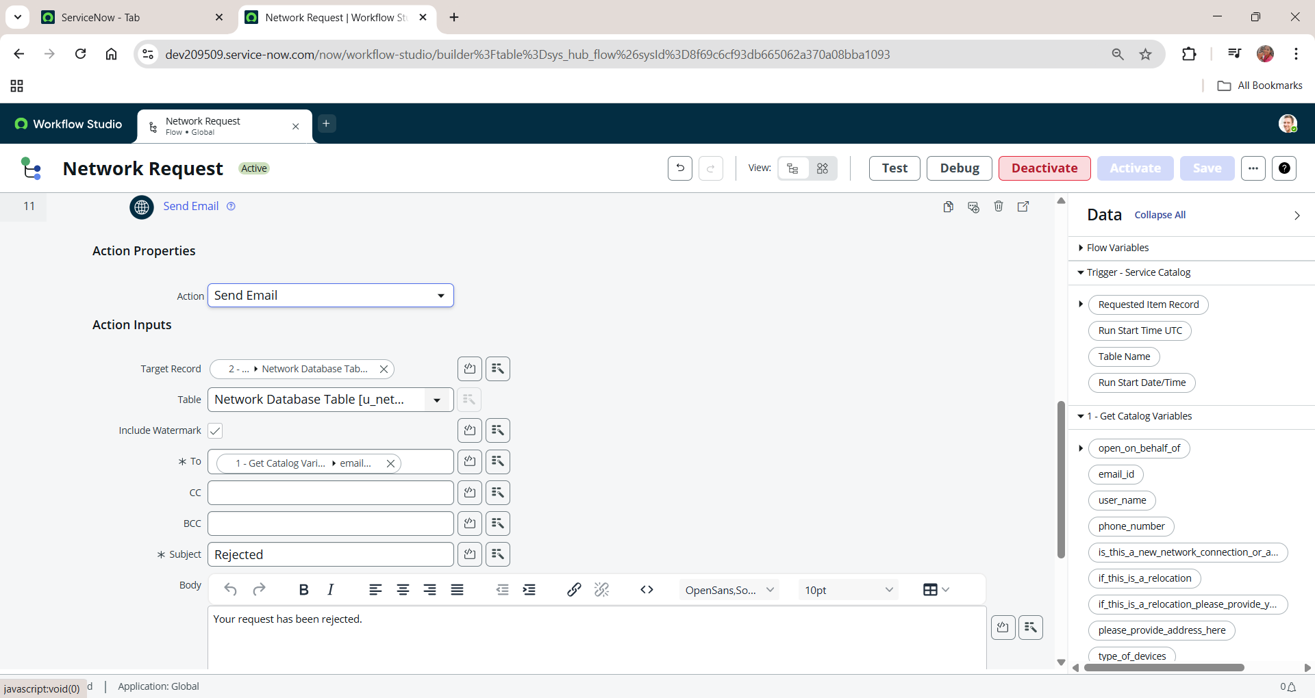

**d. Flow Chart**

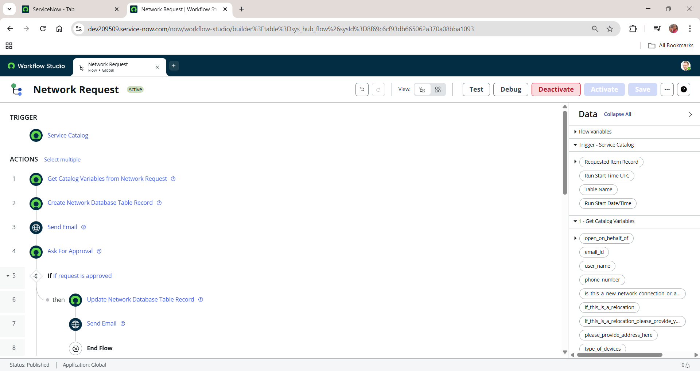

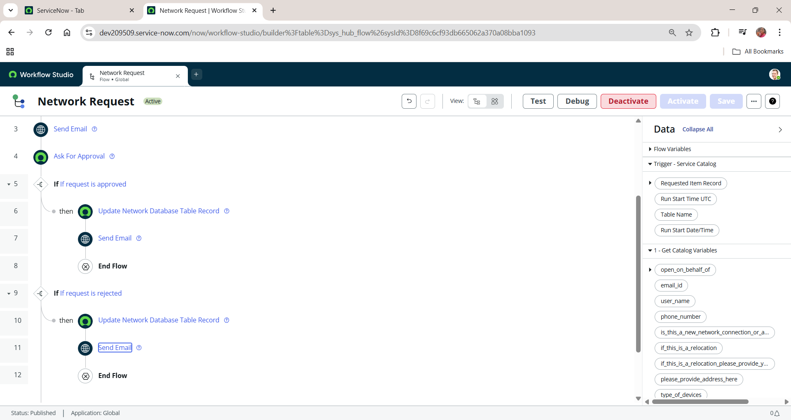

**Final Testing in End User portal & Instance**

**a. service portal**

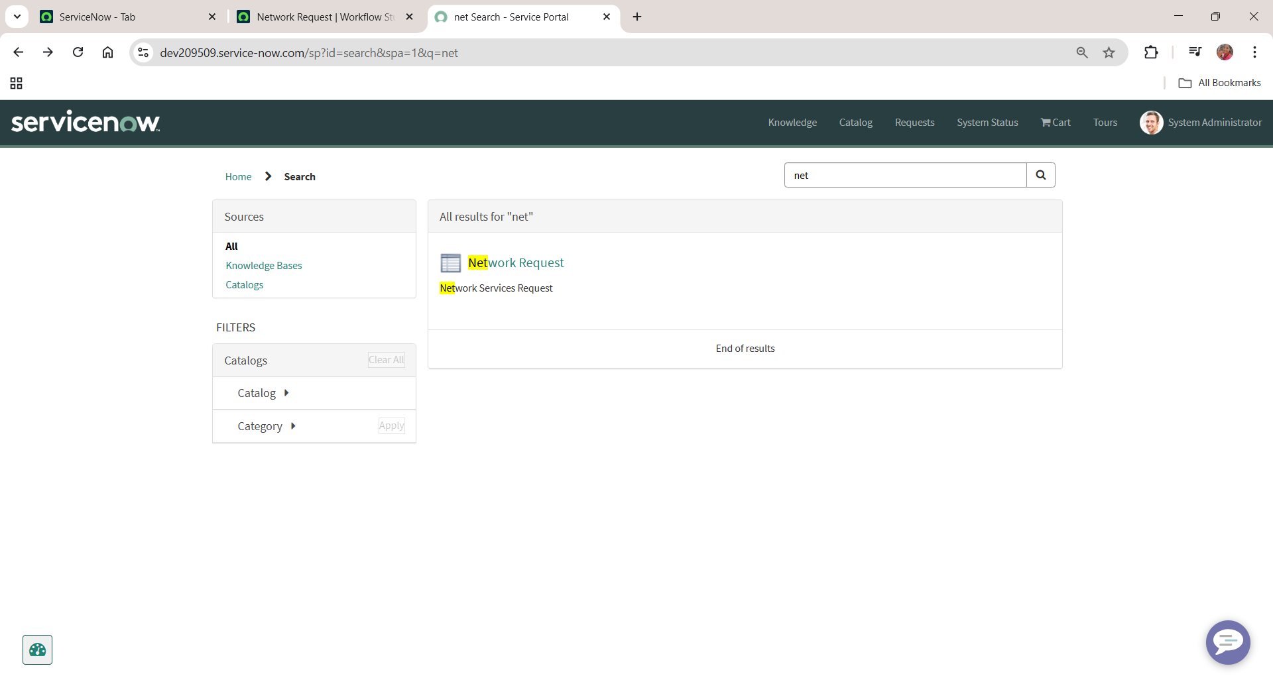

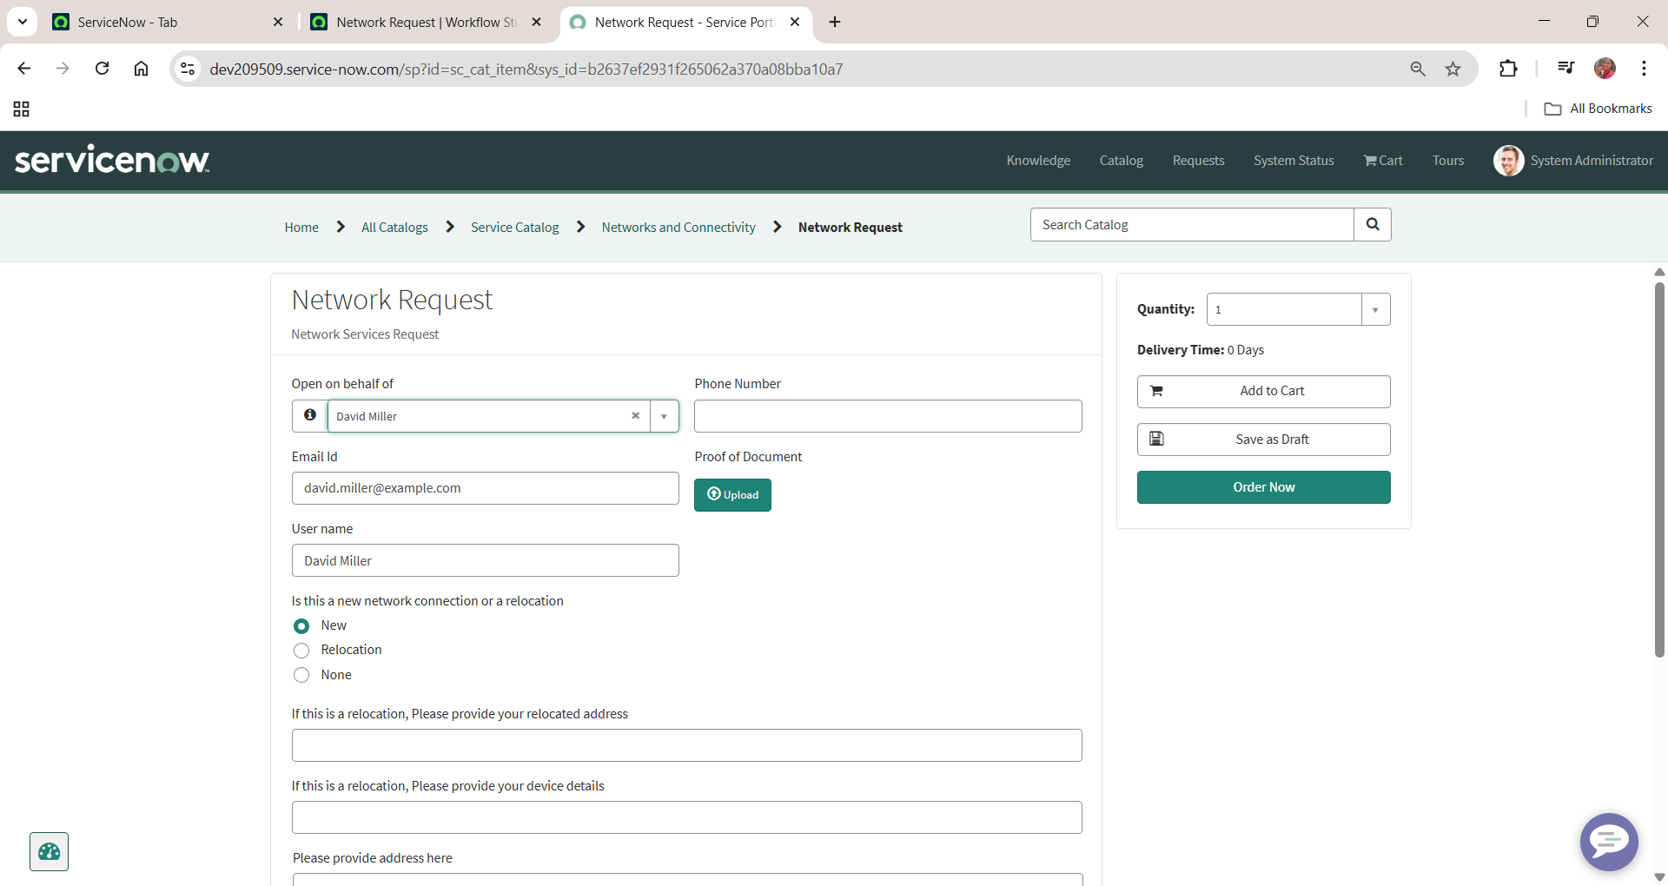

**b. Flow when request approved**

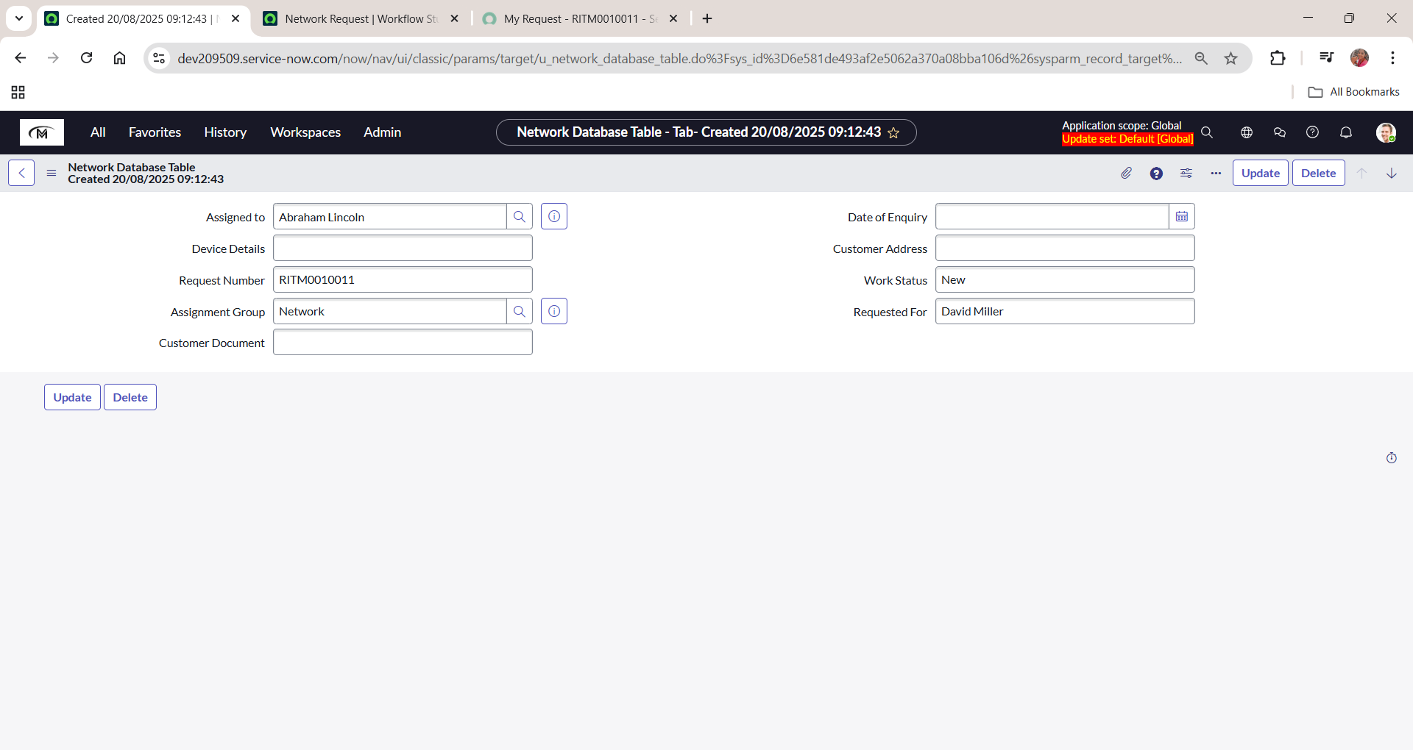

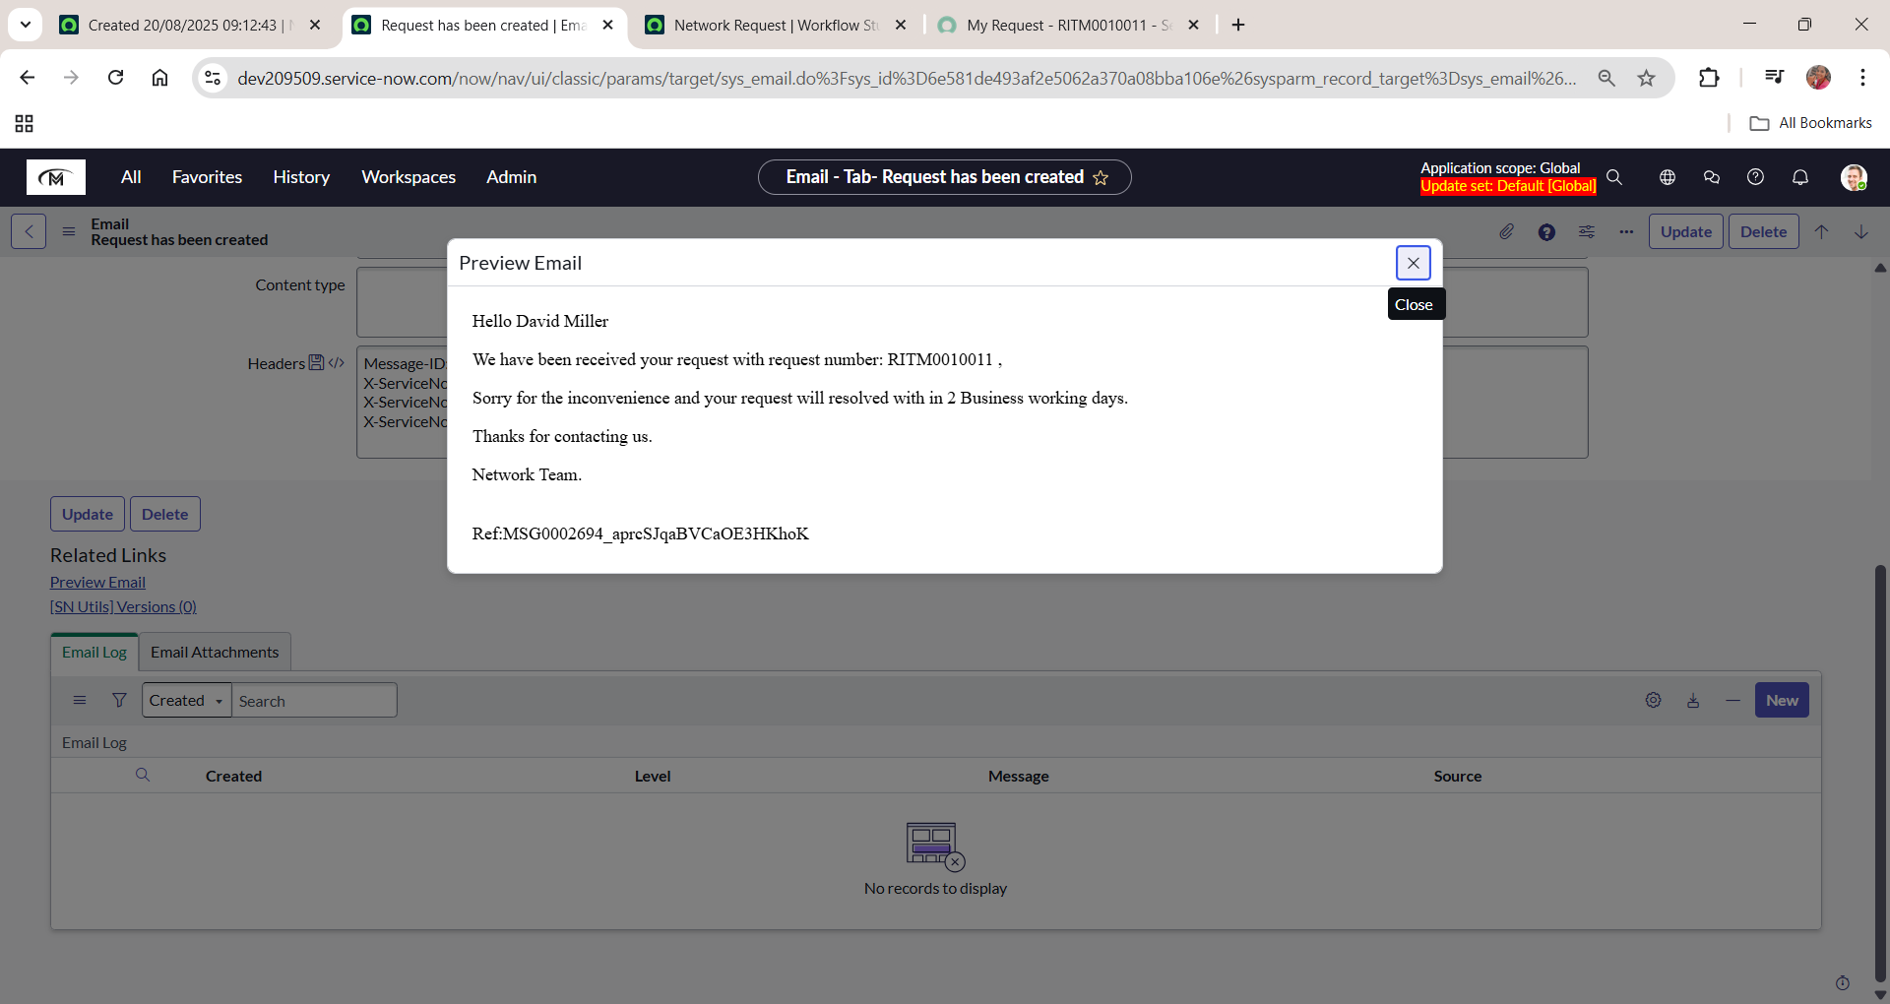

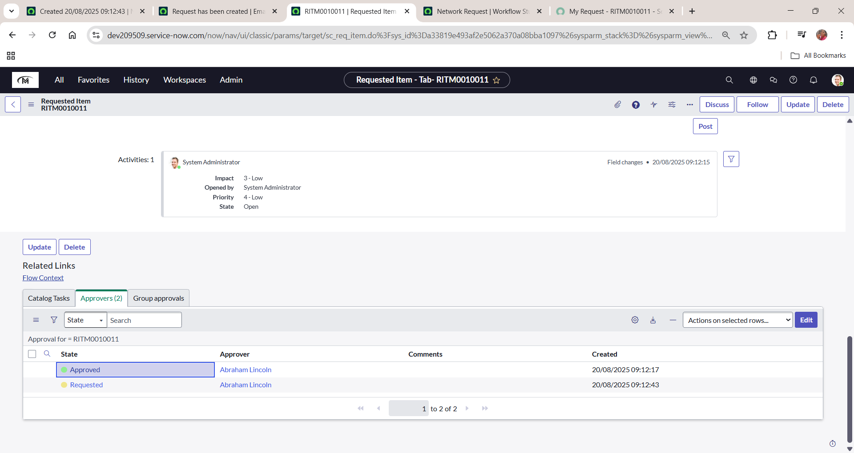

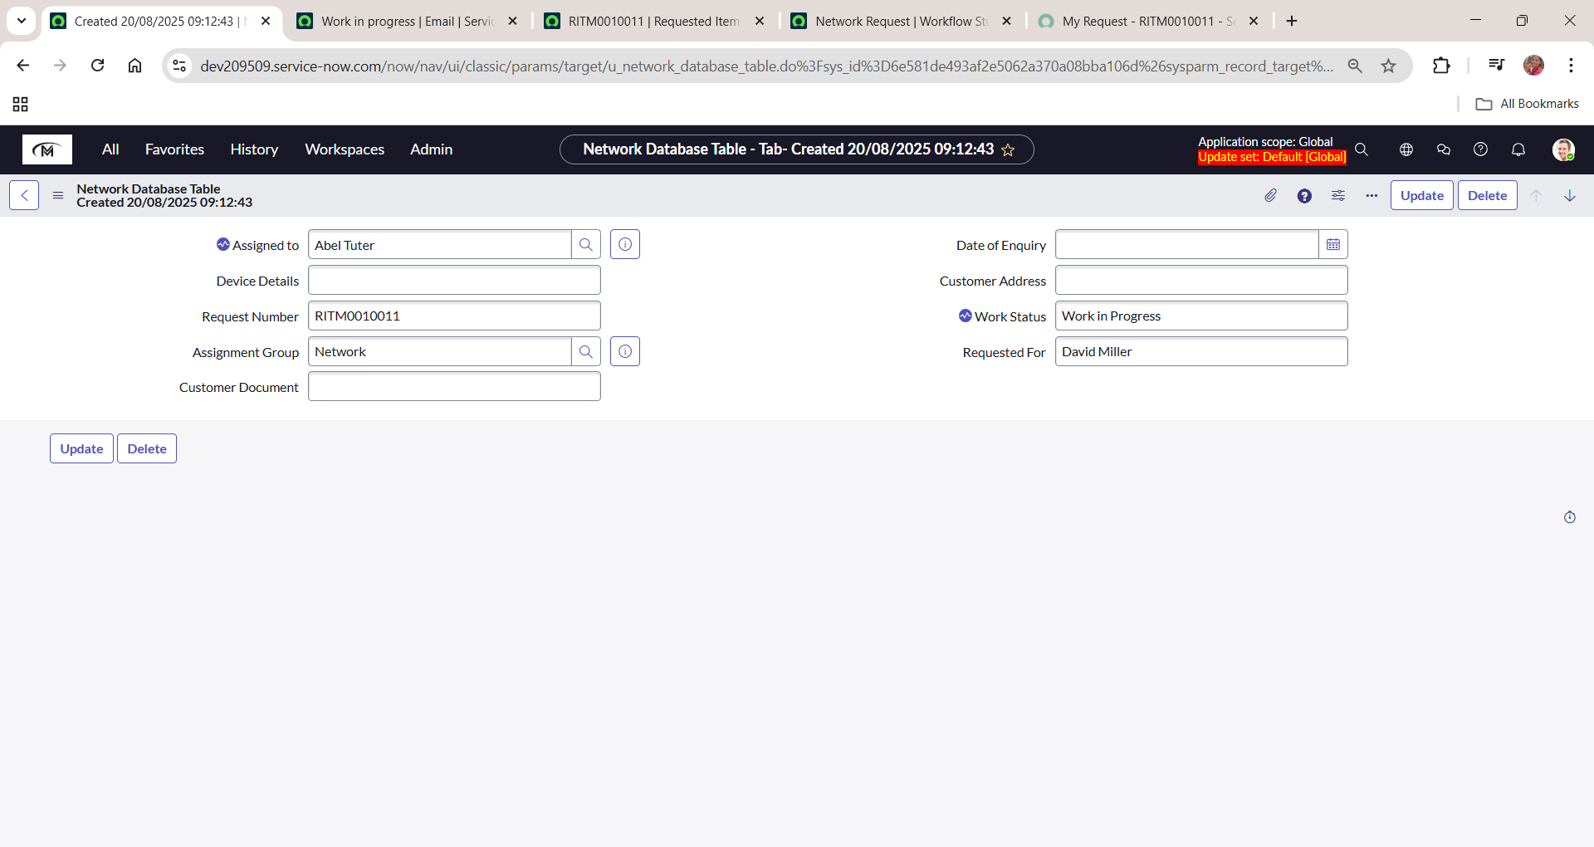

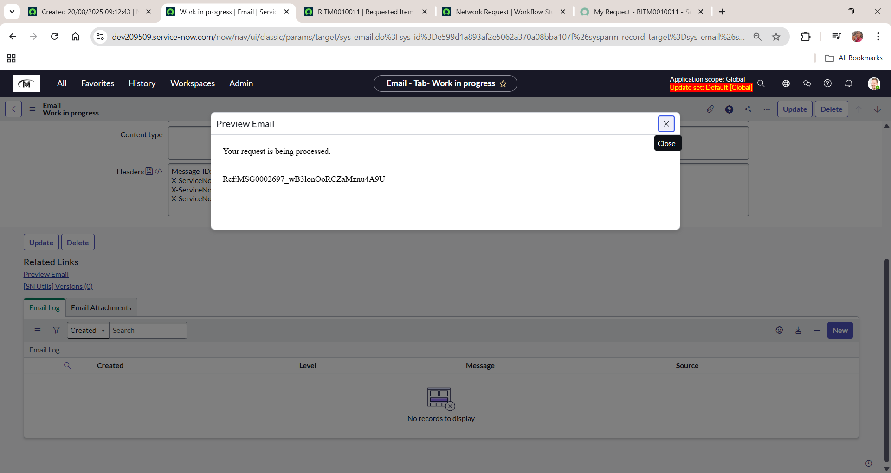

**c. Flow when request rejected**

